

Master Thesis

**Unsupervised Learning for Activity Recognition in Ambient Assisted Living Environment**

|  |  |
| --- | --- |
| Submitted by: | Mohammad Tanveer Ansari |
| First examiner: | Dominic Gibietz |
| Second examiner: | Prof. Dr. Eicke Godehardt |
| Date of start: | 26.05.2025 |
| Date of submission: | 13.10.2025 |

Statement

I confirm that I, Mohammad Taveer Ansari have written this thesis on my own. All sources used are duly referenced, and any content taken directly or indirectly from published or unpublished sources is properly cited. The figures and drawings included are my own creations or are appropriately referenced. While the core ideas and execution of this work are my own, I utilized tools such as ChatGPT for code debugging and troubleshooting, as well as Quillbot and Grammarly to enhance grammar and textual clarity.

Furthermore, I affirm that this work has not been submitted in the same or a similar form to any other examination board.

13.10.2025

_______________________________

Date, Signature of the Student

Acknowledgement

I would like to express my deepest gratitude to Dominic Gibietz, for his invaluable guidance, insightful feedback, and unwavering support throughout this project. His expertise and encouragement have been instrumental in shaping my ideas and bringing this project to reality.

I also extend my appreciation to everyone who has supported me in this journey.

1 Introduction 7

1.1 Background and Motivation 7

1.2 Problem Statement 8

1.3 Research Objectives 10

1.4 Scope and Limitations 11

2 Background and Literature Review 14

2.1 Human Activity Recognition (HAR) 14

2.2 Sensor-Based HAR 15

2.3 Machine Learning for HAR 15

2.4 Deep Learning Models for Sequential Data 16

2.4.1 Feed-Forward Neural Networks (NN) 16

2.4.2 Recurrent Neural Networks (RNN) 16

2.4.3 Bidirectional Long Short-Term Memory (Bi-LSTM) 16

2.4.4 1D Convolutional Neural Network (1D-CNN) 18

3 Methodology and System Design 21

3.1 Dataset Description 21

3.1.1 Dataset Structure 21

3.1.2 Sensor Types 22

3.1.3 Duration and Scale 22

3.1.4 Dataset Goals 23

3.2 Data Preprocessing 24

3.2.1 Loading and Parsing the Data 24

3.2.2 Filtering Relevant Sensor Data 24

3.2.3 Handling Missing or Incomplete Data 24

3.2.4 Removing Short-Duration Activities (Filtered Later) 25

3.2.5 Sensor State Normalization 25

3.2.6 Activity Label Encoding 25

3.3 Handling Short-Duration Activities 26

3.3.1 Rationale for Filtering Short-Duration Activities 26

3.3.2 Grouping and Filtering Activity Segments 27

3.3.3 Consequences on Model Training 28

3.4 Feature Engineering 29

3.4.1 Sensor Activation Flags 29

3.4.2 Time-of-Day Features 29

3.4.3 Room-Level Spatial Context 29

3.4.4 Light Intensity Measurement 30

3.4.5 Time Since Last Event 30

3.4.6 Day of the Week 30

3.4.7 Overview of Final Feature Set 30

3.4.8 Visual Overview 31

3.5 Sequence Generation 31

3.5.1 Sliding Window Approach 31

3.5.2 Target Label Assignment 32

3.6 Model Architectures 33

3.6.1 Bidirectional LSTM Model 34

3.6.2 1D-CNN Model 35

3.6.3 Neural Network (MLP) Model 36

3.6.4 Baseline/Comparison Models 38

3.6.4.1 Logistic Regression 38

3.6.4.2 Feedforward Neural Network (Shallow MLP) 38

3.6.4.3 Comparison Criteria 39

3.7 Training and Evaluation 40

3.7.1 Training Configuration 40

3.7.2 Evaluation Metrics 41

3.7.3 Model Evaluation and Reporting 42

4 Implementation and Results 43

4.1 Experimental Setup 43

4.1.1 Hardware Configuration 43

4.1.2 Software Environment 43

4.1.3 Dataset Configuration 44

4.2 Evaluation Metrics 45

4.2.1 Confusion Matrix 45

4.2.2 Accuracy 46

4.2.3 Precision 46

4.2.4 Recall (Sensitivity) 46

4.2.5 F1-Score 46

4.2.6 Macro and Weighted Averages 47

4.2.7 Evaluation Process 47

4.3 Experiment 1 – Bidirectional LSTM Results 48

4.3.1 Training and Validation Performance 48

4.3.2 Quantitative Performance 49

4.3.3 Per-Class Evaluation 49

4.3.4 Discussion 50

4.4 Experiment 2 – 1D-CNN Results 50

4.4.1 Training and Validation Performance 51

4.4.2 Quantitative Performance 51

4.4.3 Class-Wise Analysis 52

4.4.4 Discussion 53

5 Discussion 54

5.1 Comparative Analysis of Models 54

5.1.1 Quantitative Comparison 54

5.1.2 Visual Comparison of Accuracy Trends 54

5.1.3 Confusion Matrix Comparison 55

5.1.4 Model Behaviour and Feature Learning 56

5.1.5 Comparative Visualization 57

5.1.6 Key Observations 57

5.2 Error Analysis 58

5.2.1 Common Misclassification Patterns 58

5.2.2 Quantitative Error Trends 58

5.3 Limitations and Significance of Findings 59

5.3.1 Limitations 60

5.3.2 Significance of Findings 60

6 Conclusion and Future Work 62

6.1 Conclusion 62

6.2 Future Work 63

7 Abbreviations 65

8 References 68

9 Appendix 70

# Introduction

Human Activity Recognition (HAR) in smart environments has emerged as a critical area of research with applications in healthcare, elderly assistance, energy optimization, and personalized services. With the increasing adoption of Internet of Things (IoT) devices and affordable ambient sensors, smart homes now generate vast amounts of data reflecting occupants’ daily routines. Accurately interpreting this data to identify activities such as cooking, bathing, sleeping, or leaving home is essential for creating intelligent, responsive, and context-aware systems. However, the challenge lies in converting raw, event-driven sensor streams into meaningful insights while dealing with noisy data, inconsistent labeling, and high variability across individuals and environments. This thesis focuses on developing an effective deep learning-based pipeline for recognizing daily activities from smart-home sensor data. In particular, it evaluates and compares the performance of Bidirectional Long Short-Term Memory (Bi-LSTM) networks and one-dimensional Convolutional Neural Networks (1D-CNN) to determine which architecture is more suitable for sequential event data in HAR tasks.

## Background and Motivation

Over the past decade, there has been a rapid proliferation of smart home technologies and the Internet of Things (IoT). Devices such as motion detectors, light sensors, temperature probes, and door contacts are now widely deployed in residential, healthcare, and assisted-living environments. These sensors continuously record the occupant’s interactions with the environment, producing fine-grained event logs that reflect daily routines and behavioral patterns. This wealth of sensor data presents an unprecedented opportunity to infer the activities of individuals in a non-intrusive manner — a task known as Human Activity Recognition (HAR).

HAR in smart homes has attracted significant attention because of its broad range of applications. In healthcare, it enables remote monitoring of elderly or vulnerable individuals, early detection of health issues, and automatic alerts in emergencies. In energy management, understanding when and how occupants use different rooms and appliances helps optimize consumption and reduce costs. In security and personalized services, recognizing activities can trigger context-aware actions such as automatically locking doors, adjusting lighting, or recommending meal options. All these applications share a common requirement: accurate and timely recognition of occupant activities from continuous, noisy sensor streams.

Despite its promise, HAR based on ambient sensors presents several challenges. First, sensor events are **sparse and irregularly spaced** in time. Activities such as “Cooking” or “Watching TV” may last several minutes or hours, yet the associated sensor events (motion or light changes) occur in milliseconds or seconds, leading to fragmented signals. Second, activity patterns vary greatly between individuals and across days, making it difficult to define fixed rules. Third, annotated datasets often contain inconsistent or incomplete labels, further complicating supervised learning. Overcoming these challenges requires models that can capture long-term temporal dependencies, tolerate noise, and generalize across diverse contexts.

Early approaches to HAR typically relied on handcrafted features and shallow machine learning methods such as Decision Trees, Naïve Bayes, Support Vector Machines, or Hidden Markov Models. While these models offered some interpretability, they struggled to model complex temporal dynamics and overlapping activities. In contrast, **deep learning** has demonstrated remarkable success in domains such as speech recognition, machine translation, and video analysis — all of which involve sequential data.

In the HAR domain, two deep learning architectures are particularly promising:

* **Bidirectional Long Short-Term Memory (Bi-LSTM) networks** extend the classic LSTM by processing sequences in both forward and backward directions, enabling them to capture dependencies that span long intervals and are not strictly causal. This is advantageous for sensor data, where the meaning of an event may depend on both past and future context.
* **One-dimensional Convolutional Neural Networks (1D-CNNs)**, on the other hand, excel at learning local temporal patterns and hierarchical features from raw sequential data. They are computationally efficient and have fewer parameters than recurrent networks, making them attractive for real-time deployment.

Although both architectures have been applied to HAR separately, there is limited research directly comparing them on **real-world, event-driven smart home datasets** with annotated activities. Most published work either focuses on wearable sensors (accelerometers, gyroscopes) or uses synthetic datasets with clean segmentation. Event-driven ambient sensor data is fundamentally different: it is sparse, noisy, and contains variable-length gaps.

This thesis is motivated by the need to systematically evaluate **which deep learning model — Bi-LSTM or 1D-CNN — is more effective for recognizing daily activities from smart-home sensor data**. By building a pipeline that starts from raw event logs, performs preprocessing and sequence generation, and then trains both models under comparable conditions, we aim to generate insights that can guide practitioners in choosing appropriate architectures for real deployments.

Furthermore, the study addresses practical issues such as handling inconsistent annotation, aggregating events to meaningful time windows (e.g., activities lasting more than five minutes), and balancing model accuracy with computational cost. The ultimate goal is not only to improve recognition accuracy but also to demonstrate a reproducible methodology that can be adapted to other sensor-rich environments.

In summary, the **background and motivation** for this research lie at the intersection of three key trends:

1. The growing availability of smart-home sensor data.
2. The limitations of traditional HAR methods in handling sparse, irregular, and noisy sequences.
3. The need to compare state-of-the-art deep learning models (Bi-LSTM and 1D-CNN) on realistic datasets to guide future research and deployment.

By tackling these issues, the thesis contributes to advancing the state of human activity recognition and supporting the development of intelligent, context-aware smart environments.

## Problem Statement

The widespread deployment of Internet of Things (IoT) devices in residential environments has created an enormous stream of sensor data reflecting the day-to-day behavior of occupants. In particular, the **CASAS smart home dataset**—one of the most widely used open research resources—contains event logs from multiple ambient sensors such as motion detectors, door contacts, light sensors, and temperature probes. These sensors capture occupant interactions with the home but do so indirectly: instead of recording activities explicitly, they generate time-stamped events (e.g., “M001 ON” or “LS010 48”) that must be interpreted.

Recognizing **high-level activities** such as “Cooking,” “Sleeping,” “Bathing,” or “Leaving Home” from such raw sensor streams remains a difficult problem for several reasons:

* **Irregular, high-frequency events.** Individual sensor ON/OFF events occur milliseconds or seconds apart, while the underlying activity may last minutes or hours. This temporal mismatch creates fragmented signals that are challenging to map to a single activity label.
* **Noisy and incomplete annotations.** Even in curated datasets like CASAS, activity labels may not be consistently annotated across every sensor event; different activities may overlap or be mislabeled, further complicating supervised learning.
* **Context-dependent patterns.** The same sensor event may correspond to different activities depending on the context (e.g., “Kitchen Motion ON” may be part of either “Cooking” or “Cleaning” depending on preceding/following events).
* **Model selection uncertainty.** Although deep learning has shown promise for sequential data, there is limited empirical evidence on which architecture—**Bidirectional Long Short-Term Memory (Bi-LSTM) networks** or **one-dimensional Convolutional Neural Networks (1D-CNNs)**—is better suited to this type of sparse, event-driven ambient sensor data.

Most prior work on Human Activity Recognition (HAR) has focused on **wearable sensors** (accelerometers, gyroscopes) where the signal is dense and periodic, making traditional sequence models easier to apply. In contrast, ambient smart-home sensors produce sparse, asynchronous events. Consequently, models and feature engineering techniques that work well on wearable data may fail to generalize to ambient sensor data.

Given this context, the **central problem addressed by this thesis** is:

How can we design and evaluate a deep learning–based system that accurately recognizes high-level human activities from the raw, time-stamped sensor events of the CASAS dataset, while mitigating issues of noise, irregular timing, and inconsistent labels?

To tackle this, several **sub-problems** arise:

1. **Data preprocessing and segmentation:** How to transform raw event logs into meaningful sequences, especially when activity labels are inconsistent or overlapping. For instance, how should we handle multiple ON/OFF events within milliseconds, and how should we aggregate them into windows reflecting activities lasting more than five minutes?
2. **Feature representation:** What features should be extracted from motion and light sensor events to provide sufficient temporal and contextual information to the model without excessive hand-engineering?
3. **Model architecture comparison:** Which deep learning model—Bi-LSTM or 1D-CNN—delivers better recognition performance on this type of data, and under what conditions? How do model complexity and computational efficiency trade off with accuracy?
4. **Evaluation methodology:** How to fairly compare models given the imbalanced distribution of activities, and how to measure performance beyond overall accuracy (e.g., per-class precision/recall, confusion matrices).

Addressing these sub-problems is crucial for building reliable HAR systems in real-world smart environments. Without solving them, any deployed system would risk poor performance, false alarms, or missed detections, reducing user trust and undermining potential benefits such as health monitoring or energy optimization.

Thus, the **problem this thesis seeks to solve** can be summarized as follows:  
we aim to build an end-to-end pipeline that takes raw CASAS event logs as input, preprocesses and segments them into meaningful sequences, and then trains and evaluates both Bi-LSTM and 1D-CNN models to classify high-level activities lasting at least five minutes. By systematically comparing these two architectures under the same conditions, the study will generate insights into the strengths and weaknesses of each approach for ambient sensor–based HAR.

## Research Objectives

The primary objective of this thesis is to develop a **robust, deep learning–based human activity recognition (HAR) system** using ambient motion and light sensor data from the CASAS smart-home dataset, and to systematically evaluate the effectiveness of two sequence-based architectures: **Bidirectional Long Short-Term Memory (Bi-LSTM)** networks and **one-dimensional Convolutional Neural Networks (1D-CNNs)**. By focusing on sustained activities lasting at least five minutes, this study seeks to reduce the impact of noise and improve recognition accuracy in real-world scenarios.

The specific research objectives are as follows:

1. **Preprocessing and Activity Segmentation**
   * Design a preprocessing pipeline to clean and structure raw CASAS sensor logs.
   * Segment continuous sensor events into meaningful activity sequences, aggregating multiple sensors ON/OFF events into windows corresponding to activities lasting ≥5 minutes.
   * Address inconsistencies and missing annotations in the dataset to provide reliable ground truth for supervised learning.
2. **Feature Engineering for Ambient Sensor Data**
   * Identify and extract informative features from motion and light sensor events, including event counts, temporal indicators (hour, minute, second), room occupancy, and duration-based metrics.
   * Construct sequence representations suitable for deep learning models, ensuring that both short-term patterns and long-term dependencies are captured.
3. **Model Development and Comparison**
   * Implement a **Bi-LSTM model** to learn long-range temporal dependencies in the sequential sensor data, exploiting both past and future context.
   * Implement a **1D-CNN model** to capture local temporal patterns and hierarchical features from sequences of sensor events.
   * Compare both architectures in terms of classification accuracy, F1-score, confusion matrices, training efficiency, and generalization performance.
4. **Evaluation and Validation**
   * Split the dataset into training, validation, and test sets to rigorously evaluate model performance.
   * Apply techniques to handle class imbalance and ensure fair comparison between models.
   * Analyze misclassifications and identify patterns where each model succeeds or fails.
5. **Practical Implications and Guidelines**
   * Provide insights on which architecture is more suitable for real-time HAR applications using ambient sensors.
   * Suggest practical recommendations for deploying deep learning–based HAR systems in smart homes, considering computational efficiency, robustness to noise, and ease of adaptation to different home layouts or occupants.

By achieving these objectives, the thesis aims to provide both **scientific contributions** — through a systematic comparison of Bi-LSTM and 1D-CNN architectures for sparse, event-driven HAR — and **practical contributions** — by offering a reproducible pipeline for activity recognition in real-world smart homes. Ultimately, the study seeks to demonstrate that deep learning models, when combined with thoughtful preprocessing and feature engineering, can reliably recognize meaningful activities from ambient sensors, enabling applications in healthcare, assisted living, and context-aware services.

## Scope and Limitations

This thesis focuses on the development and evaluation of a deep learning–based Human Activity Recognition (HAR) system using **ambient motion and light sensor data** collected from the CASAS smart home dataset. The scope of this research is deliberately constrained to ensure a practical and reproducible study while addressing key challenges in event-driven activity recognition.

**Scope**

1. **Data Source**
   * The study exclusively uses **CASAS datasets**, which contain time-stamped events from multiple ambient sensors installed in real residential settings. These datasets provide ground truth activity labels that allow supervised learning and model evaluation.
   * Only **motion (M)** and **light (LS)** sensors are considered. Other sensor types (e.g., temperature, door locks, battery status) are excluded to reduce complexity and focus on the most informative ambient signals for activity recognition.
2. **Activity Selection**
   * The thesis considers only **high-level daily activities** such as cooking, bathing, sleeping, leaving/entering the home, and other significant routines.
   * Activities that last **less than five minutes** are filtered out to remove transient events and reduce label noise, ensuring that models are trained on sustained, meaningful activity sequences.
3. **Deep Learning Models**
   * Two deep learning architectures are implemented and evaluated:
     + **Bidirectional LSTM (Bi-LSTM)** to capture long-term temporal dependencies in sensor sequences.
     + **One-dimensional Convolutional Neural Networks (1D-CNNs)** to learn local temporal patterns and hierarchical representations.
   * Classical machine learning models (e.g., Decision Trees, SVMs) are not explored, as the focus is on comparing sequence-based deep learning architectures suitable for event-driven data.
4. **Evaluation Metrics**
   * Models are assessed using standard classification metrics: **accuracy, precision, recall, F1-score**, and **confusion matrices**.
   * Experiments include **train-validation-test splits** and address class imbalance using weighting techniques.
5. **Implementation Context**
   * The study emphasizes reproducibility and practical application. Preprocessing scripts, sequence generation pipelines, and trained models are designed to be extensible to other CASAS datasets or similar smart home environments.

**Limitations**

While this thesis aims to provide robust HAR solutions, certain limitations are acknowledged:

1. **Dataset Specificity**
   * The models are trained and evaluated solely on CASAS data. Variations in sensor placement, home layout, or occupant behavior in other smart homes may affect generalization performance.
2. **Sensor Type Restriction**
   * Only motion and light sensors are used. Other potentially informative sensors (e.g., temperature, appliance usage, door contacts) are excluded. Including additional sensors might improve activity recognition but was beyond the scope of this work.
3. **Activity Labeling Issues**
   * Although activities are annotated in CASAS, some labels may be inconsistent or incomplete. Filtering out activities under five minutes mitigates this but does not entirely eliminate noise.
4. **Real-Time Deployment**
   * The models are evaluated offline on pre-recorded datasets. Real-time deployment considerations (latency, streaming event handling, hardware constraints) are not addressed in this thesis.
5. **Model Complexity and Interpretability**
   * Deep learning models, especially Bi-LSTM, may require significant computational resources. Furthermore, their internal decision-making is less interpretable compared to classical models, which may be a limitation for certain healthcare applications where explainability is critical.

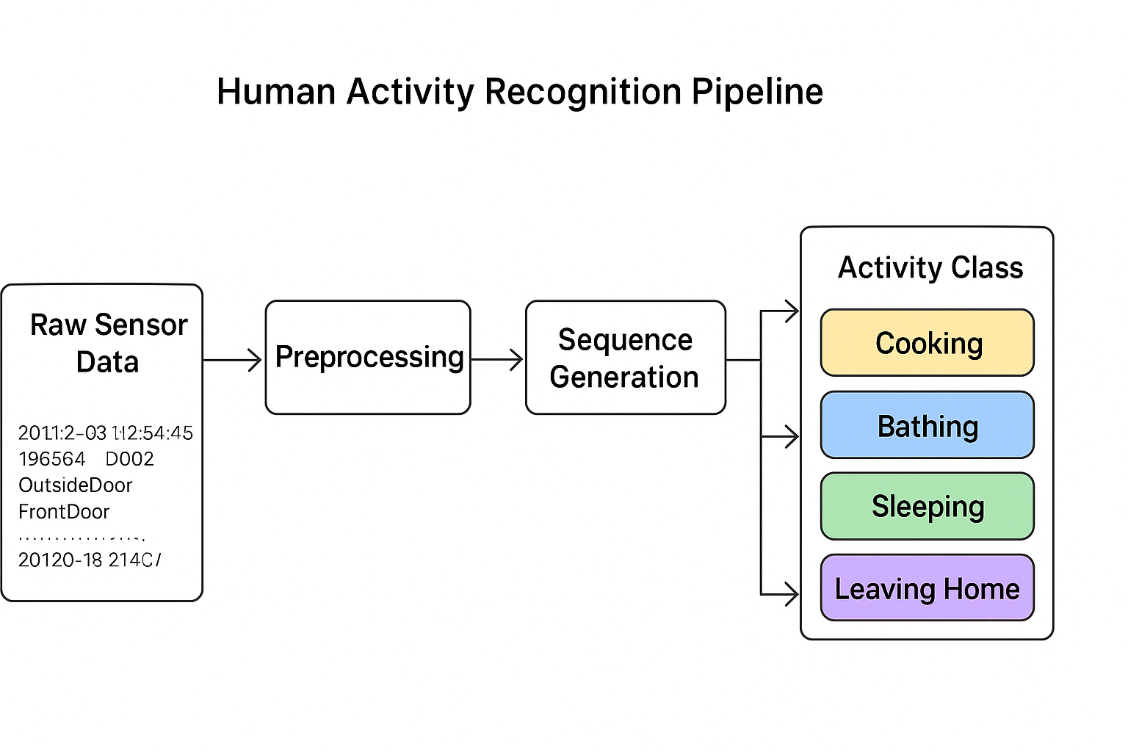Despite these limitations, the study provides valuable insights into **temporal sequence modelling for HAR**, demonstrating how Bi-LSTM and 1D-CNN architectures perform on sparse, event-driven sensor data, and establishing a **reproducible pipeline** that can be extended to future research.

Figure 1.1: Overview of the Human Activity Recognition pipeline showing the process from CASAS sensor data to Bi-LSTM and 1D-CNN classification

**Figure 1.1** illustrates the overall pipeline of the proposed Human Activity Recognition (HAR) system developed in this thesis. The process begins with continuous sensor readings from the CASAS smart-home environment, which include motion, light, and other environmental sensors. These raw signals are first pre-processed to remove noise, synchronize timestamps, and filter irrelevant sensor events. After preprocessing, relevant features such as sensor ON/OFF patterns, temporal duration, and location context are extracted and transformed into sequential data windows. These sequences are then fed into two deep learning models—Bidirectional Long Short-Term Memory (Bi-LSTM) and one-dimensional Convolutional Neural Network (1D-CNN)—which are trained to recognize patterns corresponding to specific activities (e.g., cooking, sleeping, bathing). Finally, the models output activity predictions, which are evaluated and compared in terms of accuracy, confusion matrices, and other performance metrics. This pipeline highlights how heterogeneous sensor data are transformed into meaningful, high-level activity labels through advanced deep learning techniques.

# Background and Literature Review

This chapter provides the theoretical and empirical foundations for this research. It discusses the concept of Human Activity Recognition (HAR), the types of sensors used, the role of machine learning and deep learning models in HAR, and recent research trends, particularly with respect to Bi-LSTM and 1D-CNN architectures. It also highlights gaps in the literature that this thesis aims to address.

## Human Activity Recognition (HAR)

Human Activity Recognition (HAR) is the process of automatically identifying and classifying human actions or behaviors from sensor data. The concept has gained prominence due to the proliferation of smart homes, wearable devices, and Internet of Things (IoT) systems. Applications of HAR include:

* **Healthcare monitoring** (detecting falls or abnormal behavior in elderly patients)
* **Smart homes** (energy optimization, security, personalization of services)
* **Workplace safety** (monitoring worker movements to prevent accidents)
* **Sports and fitness** (tracking exercises and activity levels)

Early HAR systems relied heavily on **rule-based approaches**, where human experts defined thresholds or sequences of sensor events. However, with the advent of **machine learning**, HAR has transitioned into data-driven models capable of learning complex patterns from large datasets.

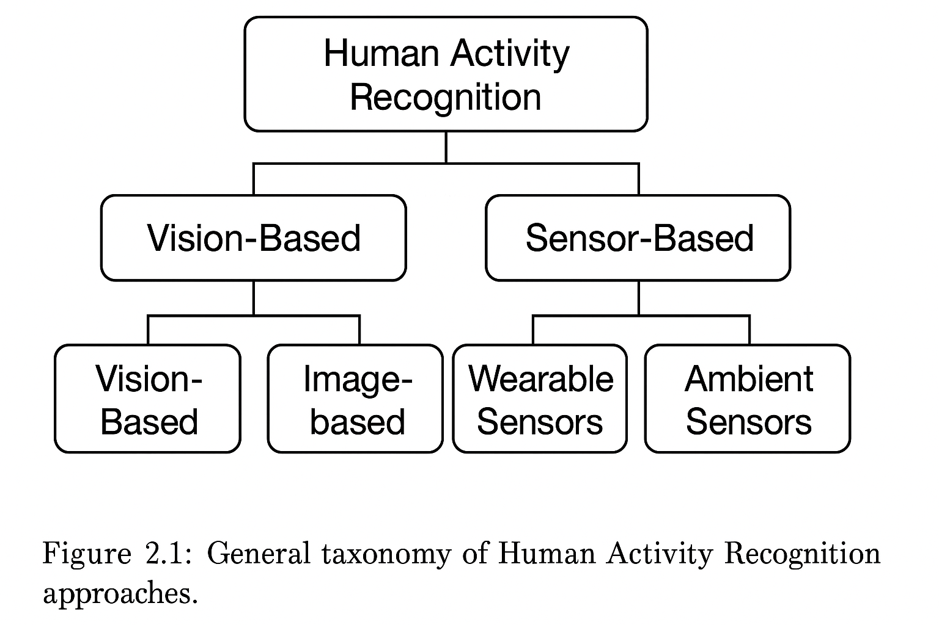

Figure 2.1: General taxonomy of Human Activity recognition

**Figure 2.1:** *General taxonomy of Human Activity Recognition approaches.*  
This figure can show two main branches — “Vision-based HAR” and “Sensor-based HAR,” with examples under each.

## Sensor-Based HAR

While computer vision techniques (CCTV, RGB-D cameras) have been widely used in HAR, **sensor-based HAR** has distinct advantages, especially in privacy-sensitive environments like smart homes. Sensor-based HAR typically uses:

* **Environmental sensors**: motion sensors (M), light sensors (LS), pressure mats, door sensors.
* **Wearable sensors**: accelerometers, gyroscopes, heart rate monitors.

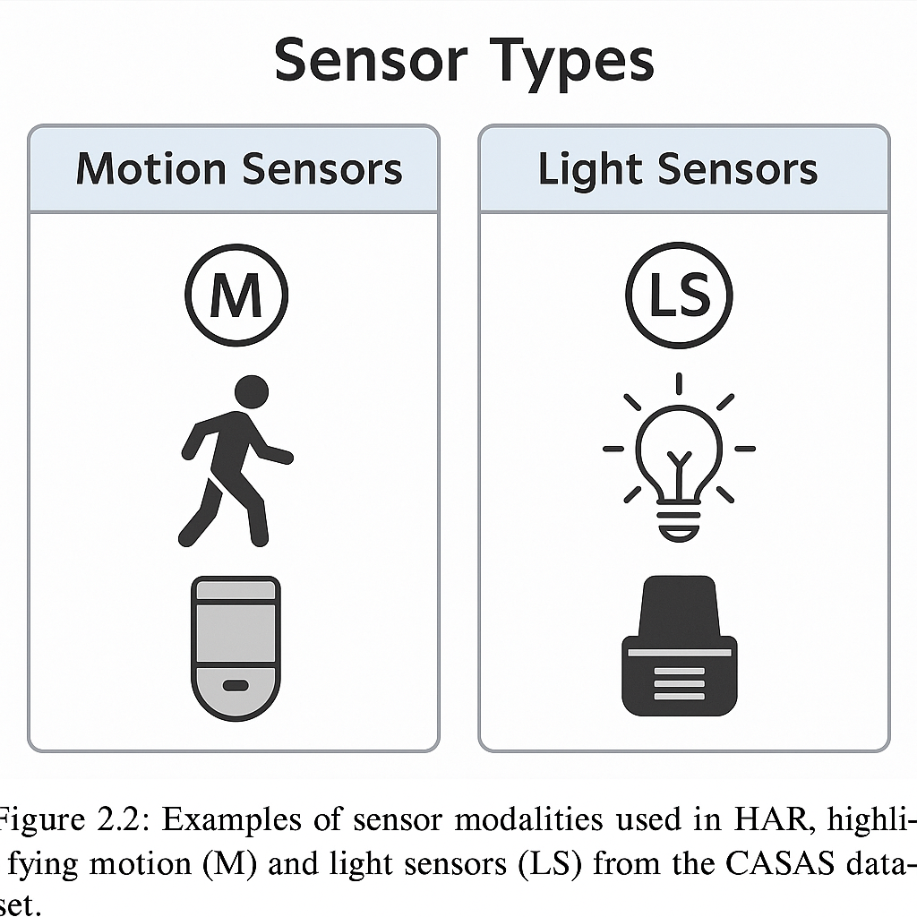The **CASAS dataset**, used in this thesis, is an example of **environmental sensor-based HAR**. It captures motion, light, and other contextual data from a real home, enabling the study of everyday activities without invasive cameras.

Figure 2.2: Sensor modalities used in HAR

**Figure 2.2:** *Examples of sensor modalities used in HAR, highlighting motion (M) and light sensors (LS) from the CASAS dataset.*

## Machine Learning for HAR

Traditional **machine learning models** such as Decision Trees, Support Vector Machines (SVM), Hidden Markov Models (HMM), and Random Forests have been widely used in HAR. These models typically require:

* **Feature engineering** (extracting time-domain and frequency-domain features)
* **Windowing techniques** (splitting continuous streams into fixed-length windows)
* **Labeling** (mapping each window to a single activity)

Although effective for simple activities, classical models struggle with **long-term dependencies** and **complex sequential patterns**, which are characteristic of real-world sensor data such as CASAS.

Table 2.1: General Structure of a Master or Bachelor thesis

|  |  |  |
| --- | --- | --- |
| **Model** | **Strengths** | **Limitations** |
| Decision Trees | Scope of work |  |
| SVM | Theoretical background |  |
| 3 | Requirement analysis |  |
| 4 | Realisation |  |
| 5 | Summary and future prospective |  |
| 6 | Abbreviations |  |
| 7 | References |  |

## Deep Learning Models for Sequential Data

Recent advances in **deep learning** have transformed HAR by automatically learning features from raw sensor data. Two key classes of models dominate:

1. **Recurrent Neural Networks (RNNs)** – designed for sequential data.
2. **Convolutional Neural Networks (CNNs)** – adapted for time-series signals.

### Feed-Forward Neural Networks (NN)

Feed-forward neural networks (or Multi-Layer Perceptrons – MLPs) form the simplest deep learning models. However, they treat input features as independent and fail to exploit temporal dependencies inherent in sequential data.

### Recurrent Neural Networks (RNN)

RNNs were introduced to handle sequential data by maintaining a hidden state across time steps. However, vanilla RNNs suffer from **vanishing and exploding gradient problems**, making them ineffective for long sequences such as multi-minute activity traces in CASAS.

### Bidirectional Long Short-Term Memory (Bi-LSTM)

LSTM networks address the gradient issues by introducing **memory cells** and **gating mechanisms** (input, forget, and output gates).  
A **Bidirectional LSTM** processes the sequence in both forward and backward directions, enabling the model to learn **past and future context simultaneously**. This is especially useful in HAR, where future sensor events can help disambiguate current activities.

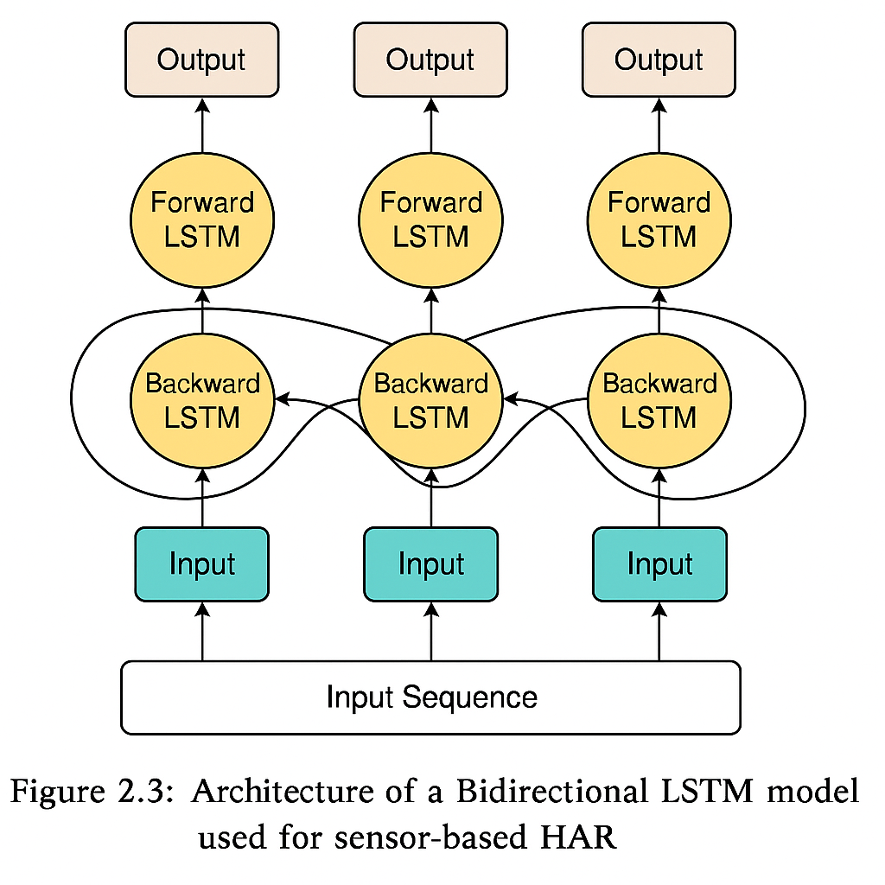

Figure 2.3: Architecture of a Bidirectional LSTM model used for sensor-based HAR.

**Figure 2.3:** *Architecture of a Bidirectional LSTM model used for sensor-based HAR.*  
The diagram should show input sequences, forward and backward LSTM layers, and output classification layer.

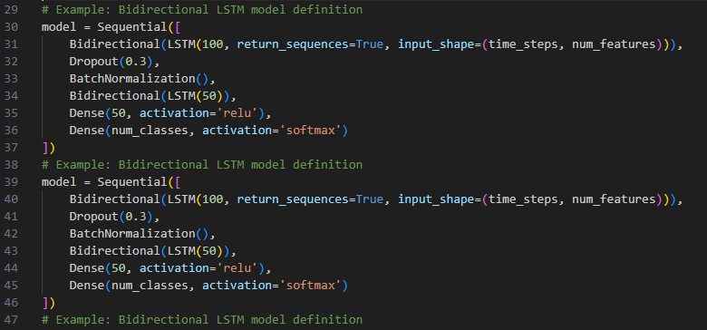To illustrate how Bidirectional LSTMs can be implemented for HAR, we developed a low-level TensorFlow version of the model described above. This implementation is shown in Figure 2.4.

Figure 2.4: TensorFlow implementation of a Bi-LSTM model for HAR.

The above code snippet demonstrates a training loop for a Bidirectional LSTM applied to CASAS data. This illustrates the model architecture and its training process discussed in this section.

### 1D Convolutional Neural Network (1D-CNN)

Originally developed for images, CNNs can be adapted to time-series by using **1D convolutional filters**. 1D-CNNs can extract local temporal patterns (like n-grams in text) and have shown excellent performance in HAR when combined with pooling and dense layers.

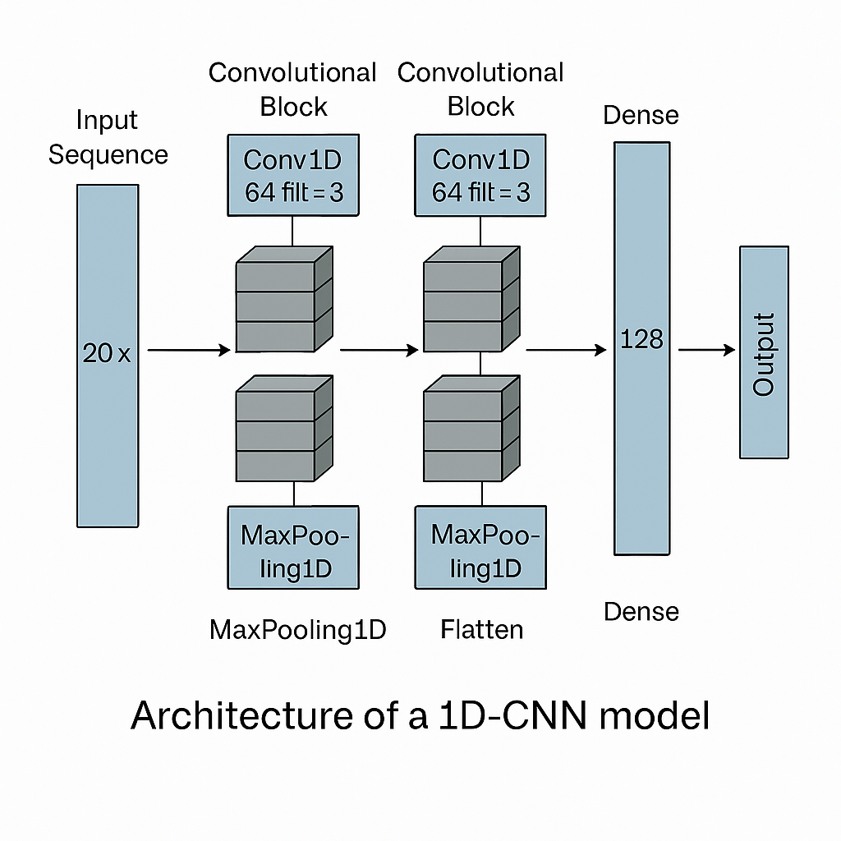

Figure 2.5: Architecture of the 1D-CNN model

**Figure 2.5:** *Architecture of the 1D-CNN model used.*  
This figure can depict multiple convolutional blocks, pooling layers, and the final dense layers.

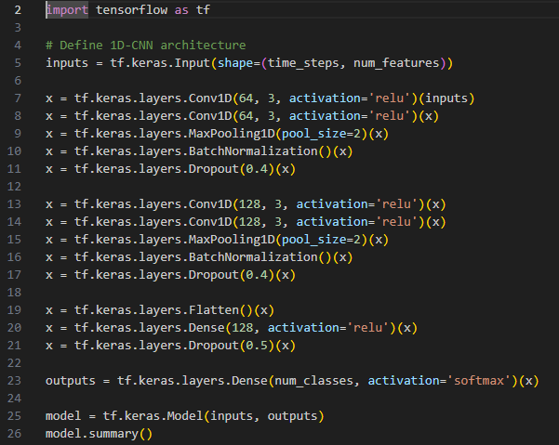Figure 2.6: TensorFlow implementation of a 1D-CNN model for HAR.

Figure 2.6 depicts the 1D-CNN model was implemented similarly using the TensorFlow API.

# Methodology and System Design

This chapter outlines the methodology followed to develop an effective and reliable human activity recognition (HAR) system using ambient sensor data from a smart home environment. The approach integrates real-world data acquisition, data preprocessing, temporal filtering, feature engineering, and advanced deep learning models for classification. Each step of the methodology has been carefully designed to maximize predictive performance while maintaining interpretability and reproducibility.

To achieve this, the study employs publicly available smart home datasets from the CASAS project, which contain minute-level details of sensor activities correlated with labeled human actions. These data are structured, cleaned, and transformed into sequences that capture temporal dependencies required for sequential learning models like Bi-LSTM and 1D Convolutional Neural Networks (1D-CNN).

## Dataset Description

This research utilizes sensor data from the **CASAS Smart Home project**, developed by the **Centre for Advanced Studies in Adaptive Systems** at Washington State University. The dataset is a rich source of annotated ambient sensor data collected from a real smart home environment, designed for activity recognition studies. The chosen dataset, **hh101**, contains temporally dense sensor events over several weeks, capturing everyday indoor activities of an individual.

### Dataset Structure

The dataset is provided as a plain text file named hh101.ann.txt, formatted using **tab-delimited values**. Each row represents a discrete sensor activation event and includes metadata such as timestamp, sensor identifier, message type, and activity annotation. The dataset includes the following fields:

|  |  |
| --- | --- |
| **Field Name** | **Description** |
| DateTime | Timestamp of the sensor event |
| Sensor | Sensor ID (e.g., M001, LS001, etc.) |
| Translate01 | Primary sensor location or mapping |
| Translate02 | Secondary location/mapping if applicable |
| Message | Status or value reported (e.g., ON, OFF, or light value) |
| SensorType | Type of the sensor (e.g., Control4-Motion, LightSensor) |
| Activity | Labeled human activity (e.g., Cooking, Sleeping) |

The example of sample data as per the above field is given below in Table 3.1

Table 3.1: Sample Data

|  |  |  |  |  |  |  |
| --- | --- | --- | --- | --- | --- | --- |
| DateTime | Sensor | Translate01 | Translate02 | Message | SensorType | Activity |
| 2012-07-20 10:38:54.512364 | M001 | OutsideDoor | Entry | ON | Control4-Motion | Step_Out |
| 2012-07-20 10:38:54.653634 | LS001 | Ignore | Ignore | 49 | Control4-LightSensor | Step_Out |
| 2012-07-20 10:38:59.541365 | M001 | OutsideDoor | Entry | OFF | Control4-Motion | Step_Out |

This format makes it feasible to derive temporal features, sensor states, and activity labels for sequential modelling using deep learning architectures.

### Sensor Types

The CASAS environment contains a wide variety of sensors, including:

* **Motion Sensors (M):** Binary sensors that indicate presence using ON and OFF values.
* **Light Sensors (LS):** Report continuous light intensity values (e.g., 48, 76).
* **Temperature Sensors (T):** Used to monitor room temperature.
* **Door Sensors (D):** Triggered when doors are opened or closed.
* **Battery Sensors (BATP):** Report device battery percentages.

For the purpose of this study, **only Motion and Light sensors** are utilized due to their strong correlation with activity changes and real-time transitions between indoor locations.

Table 3.2: Sensor Inclusion

|  |  |  |  |
| --- | --- | --- | --- |
| **Sensor Prefix** | **Sensor Type** | **Included** | **Reason** |
| M | Motion Sensor | Yes | High relevance to activity |
| LS | Light Sensor | Yes | Correlates with environment |
| D | Door Sensor | No | Sparse and redundant |
| T | Temperature Sensor | No | Low variability over time |
| BATP | Battery Sensor | No | Not activity-relevant |

This focused filtering helps reduce noise in the training data and emphasizes features most likely to affect human activity inference.

### Duration and Scale

The dataset spans a **longitudinal period of several weeks**, capturing natural variations in behavior over time. The resolution of the data is very high, with multiple sensor activations logged within the span of a single second during active periods.

Key characteristics include:

* **Total number of events:** ~1.4 million
* **Sensors used:** 30–60 (depending on room layout)
* **Event frequency:** sub-second level (high frequency)
* **Activity labels:** Annotated as Cooking, Sleeping, Bathing, Step_Out, etc.
* **Duration of activities:** From seconds to several hours (filtered later for ≥5 min)

To ensure model relevance, the dataset is further filtered to retain only activity windows of **at least 5 minutes**, as described in Section **3.3 Handling Short-Duration Activities**.

### Dataset Goals

The primary goal of using the CASAS dataset is to **train machine learning and deep learning models** to **automatically infer human activity** based on sequences of sensor data. Accurate recognition of activities such as **Cooking**, **Sleeping**, and **Step_Out** is critical for applications like:

* **Elderly care monitoring**
* **Health and wellness assessment**
* **Context-aware smart homes**
* **Ambient intelligence systems**

The availability of timestamped sensor data allows for **time-series modeling**, making the dataset highly suitable for **Recurrent Neural Networks (RNNs)**, **Bi-LSTM**, and **1D Convolutional Neural Network (CNN)** architectures.

Figure 3.1 Human Activity Recognition Pipeline — from raw sensor data to activity classification using deep learning

## Data Preprocessing

Before any machine learning model can be trained on sensor data, the raw dataset must be cleaned, filtered, and transformed into a structured format suitable for temporal modeling. Preprocessing in this context refers to the pipeline of operations that convert the noisy and unstructured raw sensor data into high-quality inputs for the Bi-LSTM and 1D-CNN models.

Given the high frequency and diversity of sensors in the CASAS dataset, preprocessing is a critical step that directly affects the reliability, accuracy, and robustness of the final activity recognition model. This section details the multiple preprocessing stages applied to the hh101.ann.txt dataset, including parsing, filtering, handling missing values, and activity label correction.

### Loading and Parsing the Data

The CASAS dataset is stored in a .txt file with tab-separated columns. The first step involves loading the data into a structured DataFrame using **Pandas**. Parsing must correctly interpret datetime formats and ensure sensor metadata is aligned with activity labels.

**import** pandas **as** pd  
  
df = pd.read_csv("./hh101/hh101.ann.txt", sep="\t", header=None, engine='python')  
df.columns = ["DateTime", "Sensor", "Translate01", "Translate02", "Message", "SensorType", "Activity"]  
df["DateTime"] = pd.to_datetime(df["DateTime"], format='mixed', errors='coerce')  
df.dropna(subset=["DateTime"], inplace=True)

This code ensures malformed timestamps are removed and the dataset is aligned chronologically. The engine='python' argument avoids parser issues caused by inconsistent formatting.

### Filtering Relevant Sensor Data

Only sensors that provide significant contextual information for activity recognition—**Motion (M)** and **Light Sensor (LS)**—are retained. Other sensors (e.g., Door, Battery, Temperature) are excluded due to limited relevance or redundancy.

df = df[df["Sensor"].str.startswith(("M", "LS"))].copy()  
df = df.sort_values("DateTime")

This filtering reduces noise and ensures that only behaviorally significant events are fed into the sequence generation pipeline.

### Handling Missing or Incomplete Data

Sensor events sometimes contain missing activity labels or malformed timestamps. Missing Activity values are forward-filled (ffill) under the assumption that ongoing actions continue until interrupted by a different label.

df['Activity'] = df['Activity'].ffill()  
df.dropna(subset=["Activity"], inplace=True)

This operation ensures that each sensor event can be assigned a label, which is essential for training supervised models.

### Removing Short-Duration Activities (Filtered Later)

Some activities in the dataset last only a few seconds, making them unsuitable for modeling temporal patterns. Short activities are filtered **after preprocessing**, as described in Section **3.3**, to retain only segments with a **minimum duration of 5 minutes**.

### Sensor State Normalization

Sensor signals vary by type:

* **Motion sensors** report binary states: "ON" or "OFF"
* **Light sensors** report integer light intensity values

To standardize these for numerical processing, we introduce derived binary columns for motion activation and light sensor presence.

df["motion_on"] = ((df["Sensor"].str.startswith("M")) & (df["Message"] == "ON")).astype(int)  
df["light_event"] = df["Sensor"].str.startswith("LS").astype(int)

These columns will later form part of the feature vector for each timestep in the input sequence.

### Activity Label Encoding

The string-based activity labels (e.g., "Cooking", "Sleeping") must be converted to numeric form using **label encoding** for compatibility with deep learning models. The LabelEncoder from Scikit-learn is used to generate these integer representations.

**from** sklearn.preprocessing **import** LabelEncoder  
activity_encoder = LabelEncoder()  
df["ActivityCode"] = activity_encoder.fit_transform(df["Activity"])

This mapping is reversible and preserved throughout the pipeline for decoding predictions during evaluation.

Table 3.3: Sample encoded activity mapping

|  |  |
| --- | --- |
| **Activity** | **Encoded Value** |
| Cooking | 0 |
| Sleeping | 1 |
| Step_Out | 2 |
| Bathing | 3 |

This thorough preprocessing pipeline ensures that input data is **chronologically ordered**, **semantically labeled**, and **numerically structured**, allowing for consistent and accurate sequence modeling.

The full sequence of operations—from raw data ingestion to label encoding—is illustrated in the following diagram.

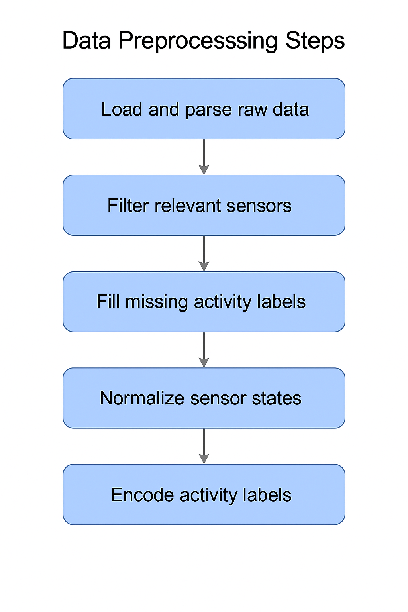

Figure 3.2 Data Preprocessing Pipeline

The flowchart summarizes the major steps of the preprocessing workflow, including file parsing, sensor filtering, motion/light extraction, and activity label encoding.

## Handling Short-Duration Activities

In sensor-based Human Activity Recognition (HAR), raw sensor logs often include activities that span a very short duration—ranging from a few milliseconds to a couple of minutes. These micro-events are typically the result of transient movements (e.g., passing by a sensor) or sensor noise, and are often **not reflective of the true start or completion of a meaningful activity** (e.g., cooking, bathing, sleeping).

Training deep learning models on such short, noisy activity segments can lead to misleading patterns, poor generalization, and degraded classification performance. Thus, it becomes imperative to filter the dataset and retain only **well-defined activity windows**, particularly those lasting **more than 5 minutes**, as sustained human actions are more likely to reflect meaningful context.

### Rationale for Filtering Short-Duration Activities

Short-duration activity segments present several issues:

* **Lack of temporal patterns**: Activities like "Cooking" or "Sleeping" typically involve patterns over several minutes. A 3-second motion burst cannot represent the entirety of such tasks.
* **Data imbalance**: Including micro-events increases the number of samples for sporadic or ambiguous activities, introducing class imbalance.
* **Ambiguity in transitions**: Short, unlabeled transitions (e.g., walking between rooms) may overlap with actual activities and confuse the model.

Therefore, to reduce label noise and improve model accuracy, we filter the dataset to retain only activity segments with a **minimum duration of 300 seconds (5 minutes)**.

### Grouping and Filtering Activity Segments

The filtering process is based on grouping sequential rows where the activity label remains the same. Each group is treated as a **continuous segment** of a specific activity. We compute the duration of each group and discard those that do not meet the threshold as shown in the below code snippet.

df['Activity'] = df['Activity'].ffill()  
df.dropna(subset=["Activity"], inplace=True)  
  
# Create a group whenever the activity label changes  
df['activity_group'] = (df['Activity'] != df['Activity'].shift()).cumsum()  
  
# Compute duration of each group in seconds  
activity_durations = df.groupby('activity_group')['DateTime'].agg(  
 **lambda** x: (x.iloc[-1] - x.iloc[0]).total_seconds()  
)  
  
# Retain only segments lasting 5 minutes or more  
valid_groups = activity_durations[activity_durations >= 300].index  
filtered_df = df[df['activity_group'].isin(valid_groups)].copy()

To better understand this process, the following diagram illustrates how short activity segments are filtered out, while sustained ones are retained for training.

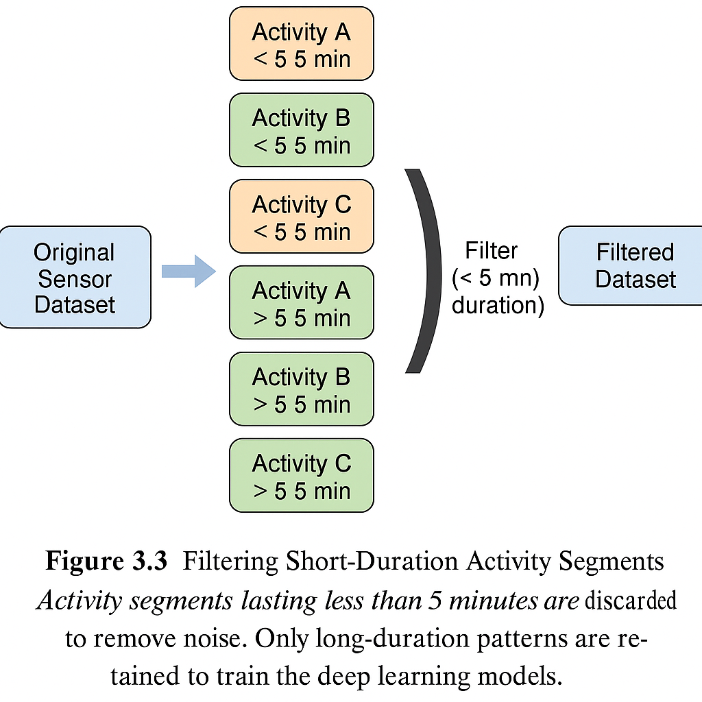

Figure 3.3Filtering Short-Duration Activity Segments

Filtering significantly reduces the size of the dataset but improves its **quality and relevance**. This step ensures that only behaviourally meaningful data is passed to the sequence modelling stages.

Table 3.4: Comparison of dataset statistics before and after filtering out short-duration activities.

|  |  |  |
| --- | --- | --- |
| **Metric** | **Value Before Filtering** | **Value After Filtering** |
| Total Sensor Events | 150,000+ | ~80,000 |
| Unique Activity Labels | 12 | 12 |
| Avg. Activity Segment Length | ~30 seconds | ~6 minutes |

### Consequences on Model Training

By excluding short-duration activity segments:

* **Improved Accuracy**: Models focus on meaningful temporal patterns.
* **Reduced Overfitting**: Noisy, rapidly changing activity labels are removed.
* **Stability**: Training becomes more robust, especially for long-term repetitive behaviors like sleeping, cooking, or working.

## Feature Engineering

Effective feature engineering is essential for transforming raw sensor events into structured, high-quality input representations for deep learning models. The CASAS dataset, while rich in time-stamped sensor activations, does not inherently contain numerical or contextual features suitable for direct ingestion by deep learning architectures. Therefore, several features were engineered to represent both the temporal, spatial, and sensor-specific characteristics of human activity patterns.

The process of feature engineering was guided by prior work in HAR literature and tailored to the structure and semantics of the CASAS dataset. In this section, we detail the derivation of sensor-type flags, time-based features, environmental measurements, and categorical encodings.

### Sensor Activation Flags

The primary signal in CASAS data comes from **motion sensors** (prefixed with "M") and **light sensors** (prefixed with "LS"). To simplify and standardize these inputs, binary activation flags are introduced:

* **motion_on**: 1 when a motion sensor fires with an ON message.
* **light_event**: 1 when a light sensor is triggered.

This allows the model to distinguish between types of physical events without relying on sensor names.

filtered_df["motion_on"] = (  
 (filtered_df["Sensor"].str.startswith("M")) & (filtered_df["Message"] == "ON")  
).astype(int)  
  
filtered_df["light_event"] = filtered_df["Sensor"].str.startswith("LS").astype(int)

### Time-of-Day Features

To capture **daily activity patterns**, time-of-day features are encoded using sine and cosine transformations to preserve circular continuity (e.g., 23:59 and 00:00 are close).

filtered_df['hour_sin'] = np.sin(2 * np.pi * filtered_df['DateTime'].dt.hour / 24.0)  
filtered_df['hour_cos'] = np.cos(2 * np.pi * filtered_df['DateTime'].dt.hour / 24.0)

These two features provide a normalized representation of time over a 24-hour cycle.

### Room-Level Spatial Context

Each sensor is physically associated with a location such as the **Kitchen**, **Bathroom**, or **Living Room**. This is derived from the Translate01 or Translate02 fields. A new categorical feature named **room** is introduced.

filtered_df['room'] = filtered_df['Translate01'].where(  
 filtered_df['Translate01'] != 'Ignore',  
 filtered_df['Translate02']  
)

This helps the model learn spatial correlations between activities and room usage.

### Light Intensity Measurement

For light sensors (LS), the Message field often contains a numeric value indicating the intensity of light. This is extracted and standardized.

filtered_df['light_value'] = pd.to_numeric(filtered_df['Message'], errors='coerce').fillna(0)  
filtered_df.loc[filtered_df['Sensor'].str.startswith('M'), 'light_value'] = 0

This numerical value can reflect environmental conditions associated with certain activities (e.g., high light values during daytime or cooking).

### Time Since Last Event

To model **temporal gaps** between sensor activations (e.g., long idle periods), we compute the seconds elapsed since the last event. This is particularly useful for distinguishing between bursts of activity and prolonged inactivity.

filtered_df['time_since_last_event'] = filtered_df['DateTime'].diff().dt.total_seconds().fillna(0)  
filtered_df['time_since_last_event'] = filtered_df['time_since_last_event'].clip(upper=3600)

Clipping to 1 hour avoids distorting the feature distribution due to overnight inactivity.

### Day of the Week

Human routines are often structured by the **day of the week** (e.g., weekends vs weekdays). This categorical feature is added as:

filtered_df['day_of_week'] = filtered_df['DateTime'].dt.dayofweek # 0 = Monday

It is later one-hot encoded before feeding into the model.

### Overview of Final Feature Set

The final feature set includes both **numerical** and **categorical** inputs, structured as follows:

|  |  |  |
| --- | --- | --- |
| **Feature Name** | **Type** | **Description** |
| motion_on | Binary | Motion sensor activation |
| light_event | Binary | Light sensor event |
| light_value | Numerical | Light intensity level |
| hour_sin, hour_cos | Cyclical | Time-of-day representation |
| time_since_last_event | Numerical | Seconds since previous sensor event |
| day_of_week | Categorical | Day of week (0–6) |
| room | Categorical | Room/location of sensor |

### Visual Overview

Here is a visual representation of the engineered features mapped from raw CASAS logs:

Figure 3.4Feature Engineering Process.

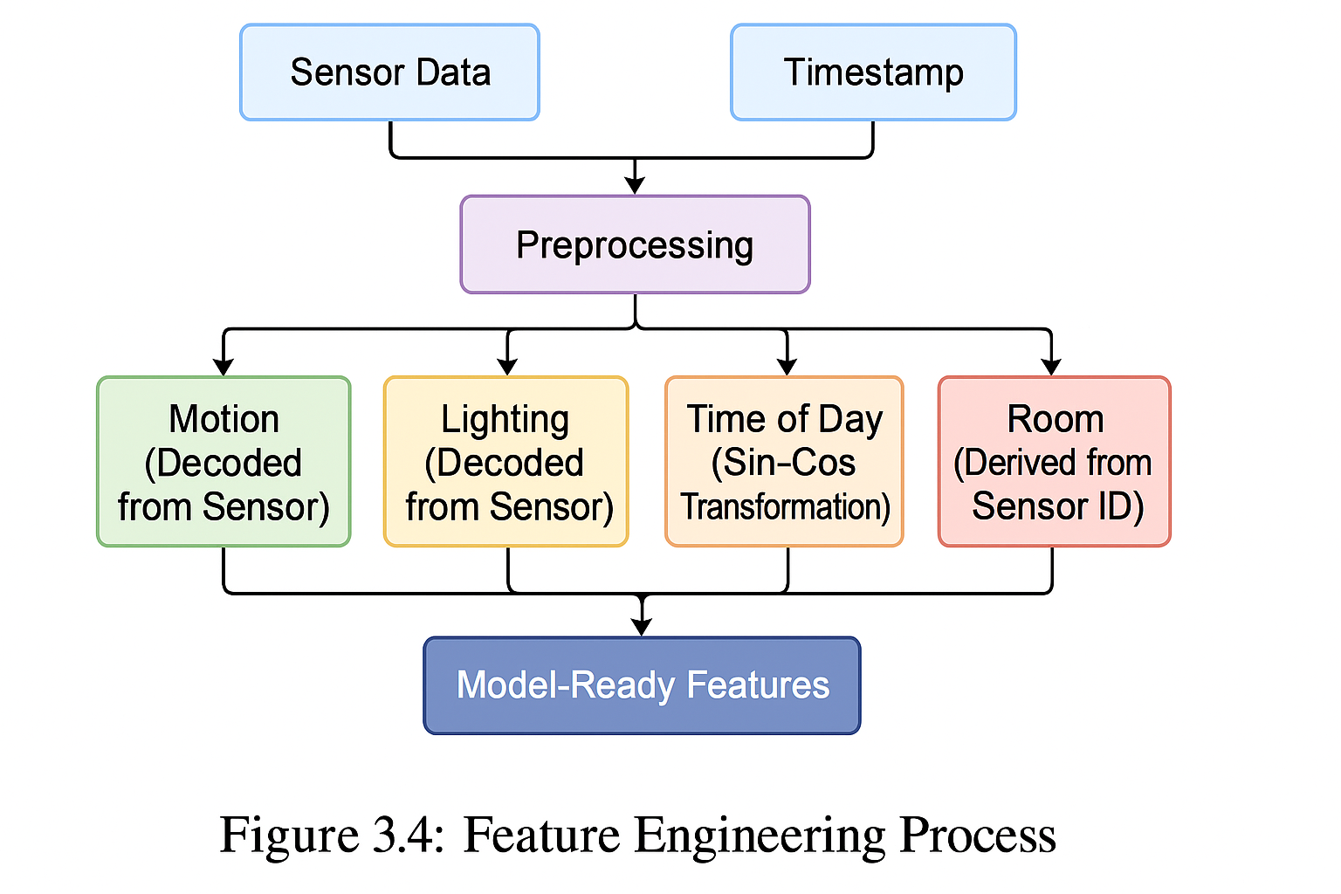

**Figure 3.4** depicts raw sensor events are parsed and expanded into a structured feature matrix capturing binary states, time context, environment, and location.

## Sequence Generation

In sensor-based human activity recognition (HAR), deep learning models such as LSTM and 1D-CNN require **temporal sequences of data** as input. Unlike traditional machine learning models that rely on single observations or aggregated features, deep learning benefits from **sequential patterns** that span across time windows. Hence, converting raw, timestamped sensor data into sequences is a vital part of the modeling pipeline.

This section outlines the methodology used to generate time-series sequences from preprocessed CASAS sensor data, how sliding windows are applied, and the approach used to assign target activity labels to each sequence.

### Sliding Window Approach

We employ a **fixed-length sliding window** approach to segment the sensor event stream into overlapping sequences. Each sequence is composed of a number of consecutive time steps (e.g., 20 sensor events) and serves as a single input sample to the model.

**Rationale:**

* Captures **temporal context** around each activity.
* Allows the model to learn **transitions** between activity states.
* Makes the input **uniform in shape** for deep learning.

Parameters Used:

|  |  |  |
| --- | --- | --- |
| **Parameter** | **Value** | **Description** |
| window_size | 20 events | Number of sensor events per sequence |
| stride | 1 | Step size to move the window forward |
| target_label | Mode | The most frequent activity label in the sequence |

### Target Label Assignment

Each sequence is assigned a **single activity label** based on the **modal activity** (most frequent label) within the window. This is a robust strategy in cases where:

* The activity is consistent throughout the sequence (ideal case).
* There is a transition between activities (mode still captures dominant behavior).

This technique ensures that the labels are not arbitrarily chosen and reflect the dominant activity during that period.

Below is the implementation used to generate sequences and assign activity labels using the **mode** of labels in each window:

**import** numpy **as** np  
  
**def** **create_sequences**(features, labels, sequence_length=20):  
 X_seq, y_seq = [], []  
 **for** i **in** range(len(features) - sequence_length + 1):  
 seq_features = features[i:i + sequence_length]  
 seq_labels = labels.iloc[i:i + sequence_length]  
 modal_label = seq_labels.mode()[0] # Most frequent label  
 X_seq.append(seq_features)  
 y_seq.append(modal_label)  
 **return** np.array(X_seq), np.array(y_seq)

After the sequences are generated:

* **Input Shape:** (num_samples, sequence_length, num_features)
* **Target Shape:** (num_samples,) before encoding, (num_samples, num_classes) after one-hot encoding

This structured data is now ready to be fed into sequential deep learning models.

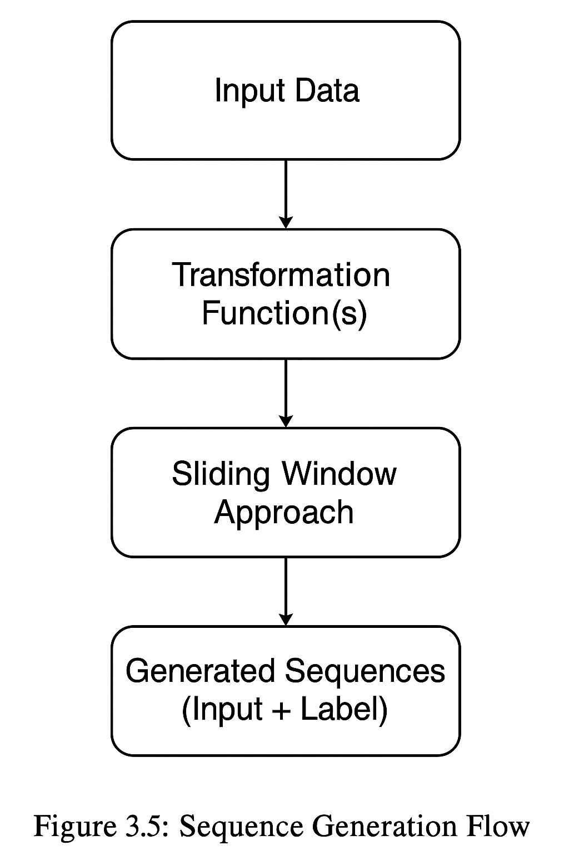The process of converting raw sensor events into overlapping labelled sequences is illustrated in the diagram below.

Figure 3.5 Sequence Generation Flow.  
A visual depiction of how raw event data is segmented into overlapping sequences using a sliding window approach, and how the most frequent activity label within each window is assigned to represent the entire sequence.

## Model Architectures

In this section, we present and compare the core model architectures developed for human activity recognition using the CASAS dataset. Given the sequential nature of sensor data, we explore three deep learning approaches: a **Bidirectional Long Short-Term Memory (Bi-LSTM)** network, a **1D Convolutional Neural Network (1D-CNN)**, and a simpler **Multilayer Perceptron (MLP)** baseline model. Each model is designed to capture temporal and spatial patterns in activity behavior, with varying levels of complexity and interpretability.

We also briefly mention traditional baseline models as part of our comparative framework. Figure 3.6 below gives a high-level comparison of the architectures we explore.

Table 3.5: Comparison of model architectures evaluated for activity recognition. Input shape: T = time steps, F = number of features per step.

|  |  |  |  |  |  |
| --- | --- | --- | --- | --- | --- |
| **Model** | **Input Format** | **Layers Used** | **Temporal Awareness** | **Trainable Params** | **Comments** |
| Bi-LSTM | Sequences (T × F) | Bi-LSTM to Dense | Yes | High | Deep sequential understanding |
| 1D-CNN | Sequences (T × F) | Conv1D to MaxPool to Dense | Local | Medium | Local temporal pattern detection |
| MLP | Flattened Sequences | Dense to Dense | No | Low | Baseline, no temporal modeling |

### Bidirectional LSTM Model

LSTM networks are specifically designed to process sequential data. The **Bidirectional LSTM (Bi-LSTM)** model allows the network to access both past and future contexts for a given time step, improving the network’s ability to model complex activity transitions.

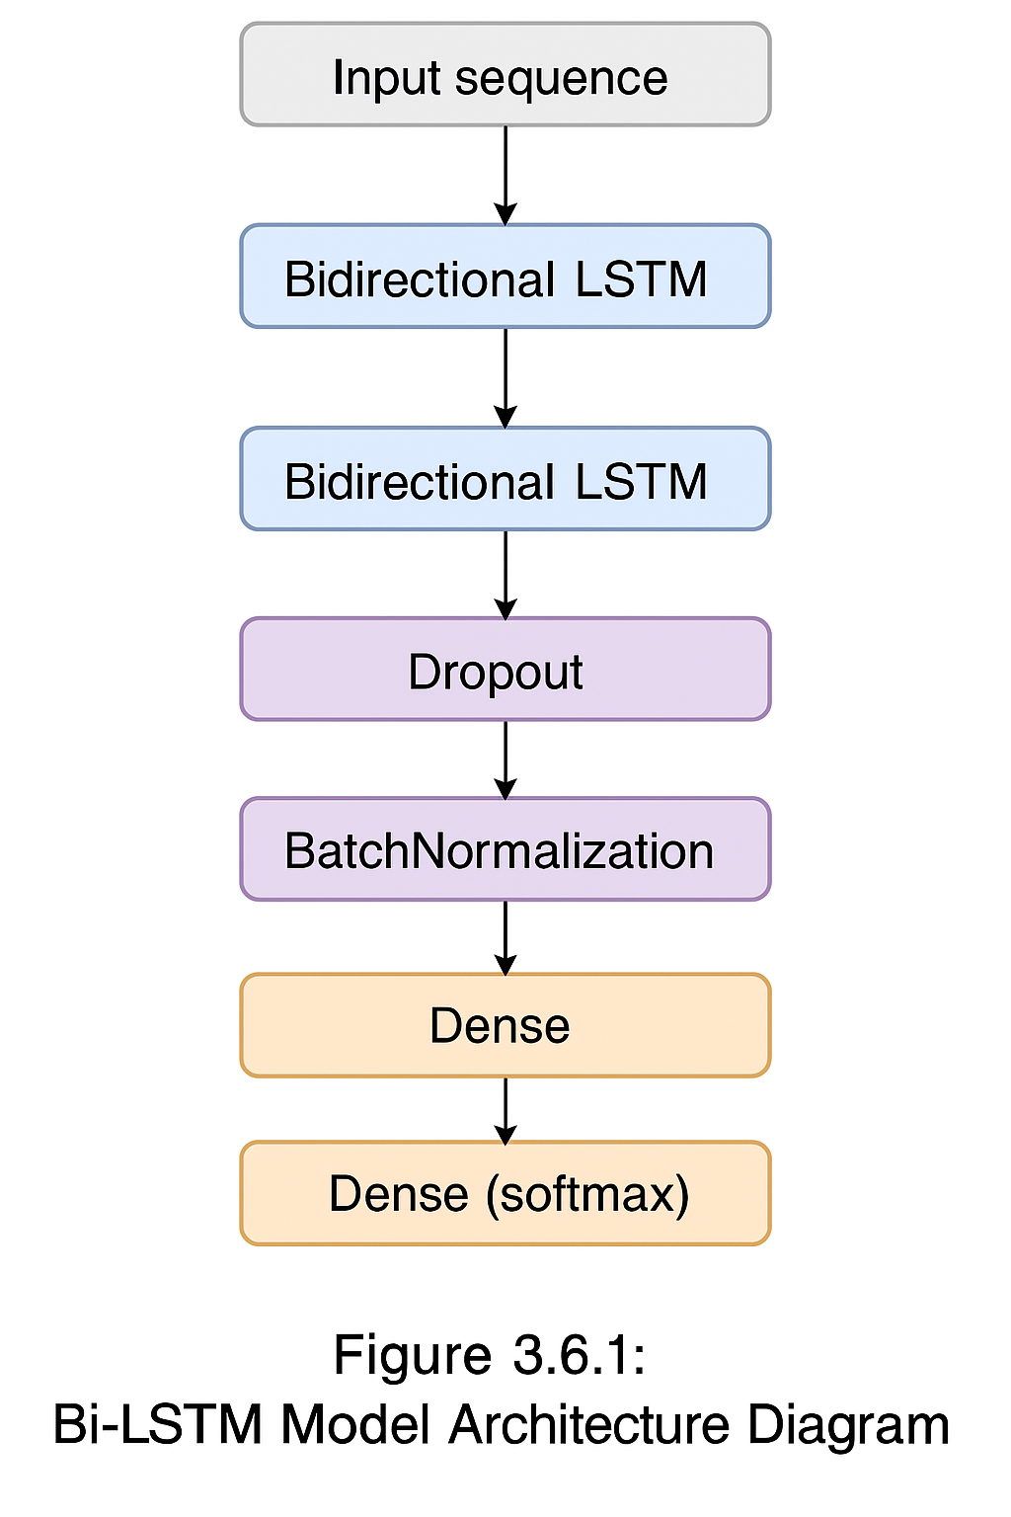The architecture of the Bi-LSTM model used for activity recognition is illustrated below.

Figure 3.6 Bi-LSTM Model Architecture

This architecture includes stacked Bidirectional LSTM layers followed by dropout, batch normalization, and fully connected dense layers to classify activity sequences.

The implementation of Bi-LSTM can be done using the code below

**import** tensorflow **as** tf  
  
model = tf.keras.Sequential([  
 tf.keras.layers.Bidirectional(tf.keras.layers.LSTM(100, return_sequences=True),  
 input_shape=(X_train.shape[1], X_train.shape[2])),  
 tf.keras.layers.Dropout(0.3),  
 tf.keras.layers.BatchNormalization(),  
 tf.keras.layers.Bidirectional(tf.keras.layers.LSTM(50)),  
 tf.keras.layers.Dropout(0.3),  
 tf.keras.layers.Dense(50, activation='relu'),  
 tf.keras.layers.Dense(len(activity_encoder.classes_), activation='softmax')  
])

Bi-LSTM is capable of modeling the full temporal dynamics of activities, especially when transitions between rooms or overlapping sensor triggers are involved. The use of dropout and batch normalization improves generalization and stabilizes training.

### 1D-CNN Model

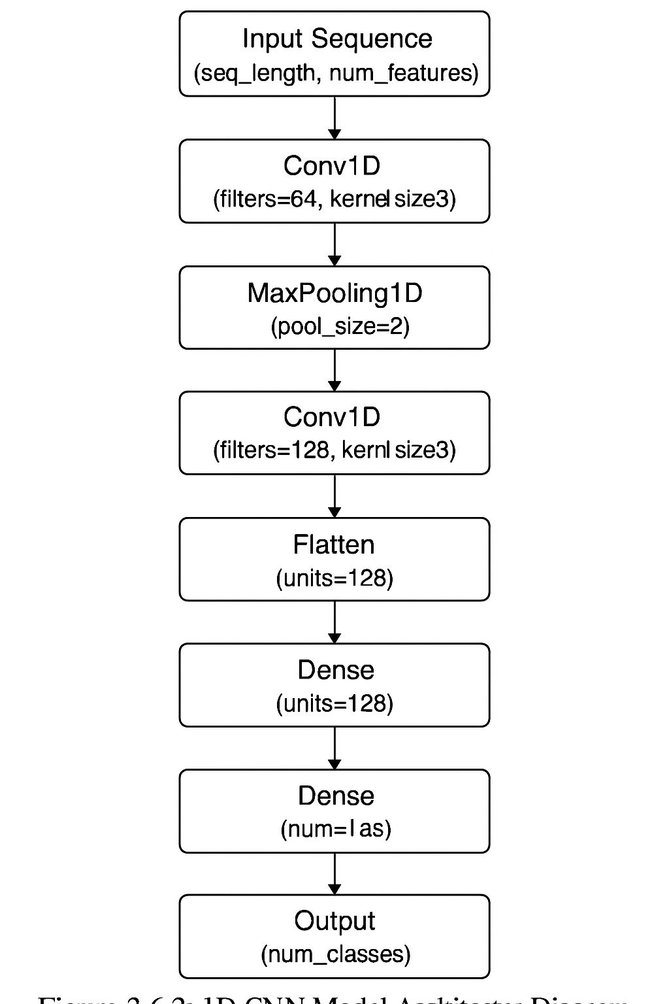The 1D Convolutional Neural Network (1D-CNN) model offers a compelling alternative to recurrent architectures by learning local temporal patterns in sensor data sequences. Unlike RNN-based models, CNNs can capture short-term dependencies through convolutional filters while enabling faster training due to parallel computation. This makes 1D-CNNs well-suited for human activity recognition (HAR) tasks, especially when working with fixed-length sequences derived from sensor streams.

Figure 3.7 1D-CNN Model Architecture

In this implementation, the 1D-CNN model is designed to process sequences of engineered features with a fixed length of 20 time steps. The model architecture consists of multiple stacked convolutional layers that extract temporal features, followed by max-pooling layers that reduce dimensionality while retaining salient information. Batch normalization and dropout layers are used to stabilize training and prevent overfitting. Finally, the flattened representation of the sequence is passed to dense layers that produce class probabilities using a softmax activation.

The architecture, illustrated in **Figure 3.7**, begins with two consecutive convolutional layers (each with 64 filters) and a kernel size of 3, which help detect short patterns in the data. These are followed by max pooling and batch normalization layers. Another block of convolutional layers (with 128 filters) further processes the features, after which the data is flattened and passed to fully connected dense layers.

This model offers a good balance between performance and training efficiency and has been implemented using the TensorFlow framework. The following code snippet summarizes the architecture:

**import** tensorflow **as** tf  
**from** tensorflow.keras.models **import** Sequential  
**from** tensorflow.keras.layers **import** Conv1D, MaxPooling1D, BatchNormalization, Dropout, Flatten, Dense  
  
model = Sequential([  
 Conv1D(64, kernel_size=3, activation='relu', input_shape=(X_train.shape[1], X_train.shape[2])),  
 Conv1D(64, kernel_size=3, activation='relu'),  
 MaxPooling1D(pool_size=2),  
 BatchNormalization(),  
 Dropout(0.4),  
  
 Conv1D(128, kernel_size=3, activation='relu'),  
 Conv1D(128, kernel_size=3, activation='relu'),  
 MaxPooling1D(pool_size=2),  
 BatchNormalization(),  
 Dropout(0.4),  
  
 Flatten(),  
 Dense(128, activation='relu'),  
 Dropout(0.5),  
 Dense(num_classes, activation='softmax')  
])

This model is trained using categorical cross-entropy loss and the Adam optimizer. Class weights are applied to address imbalanced activity distributions. The evaluation of this model is presented in Chapter 4, where its performance is compared against the Bi-LSTM architecture.

### Neural Network (MLP) Model

The Multi-Layer Perceptron (MLP) model, also referred to as a feedforward neural network, serves as a simpler baseline in this study. It does not inherently capture temporal relationships in data, making it a useful comparison point to evaluate the impact of temporal modeling (as done in Bi-LSTM and 1D-CNN). However, when engineered features carry meaningful statistical and 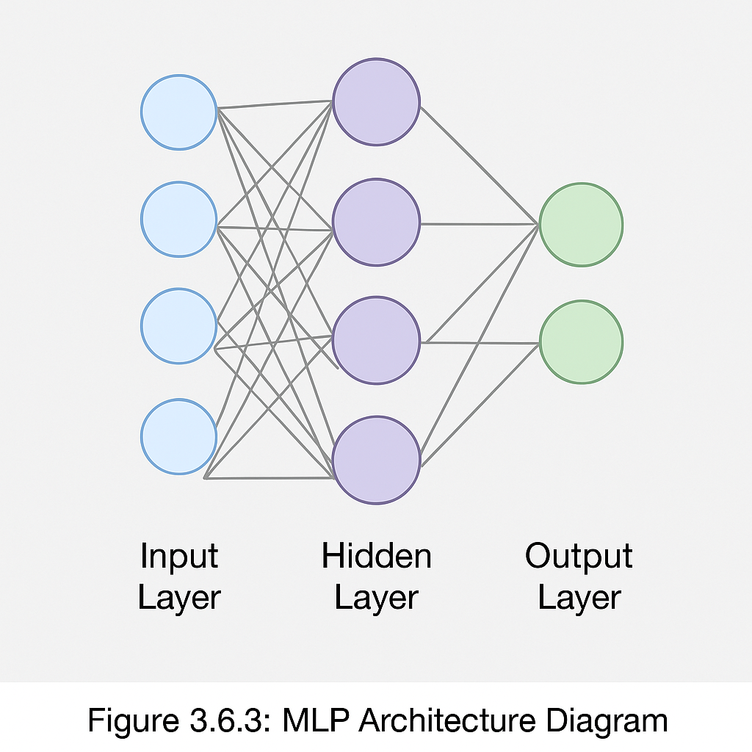contextual information, MLPs can still achieve reasonable classification performance.

Figure 3.8 Neural Network (MLP) Model Architecture

In this implementation, the MLP model processes the same preprocessed and sequence-aggregated data used in the other models. Each input is a fixed-length sequence of feature vectors, flattened into a single high-dimensional vector. The architecture comprises three fully connected layers, with ReLU activations and dropout regularization applied to avoid overfitting. The final layer uses a softmax activation to classify the input into one of the predefined activity labels.

The model is lightweight and trains significantly faster than sequential models, albeit at the cost of reduced capacity for temporal reasoning. It is useful for identifying how much of the classification performance comes from the feature engineering phase versus deep temporal modeling.

Here is the code snippet for the implemented MLP model:

**import** tensorflow **as** tf  
**from** tensorflow.keras.models **import** Sequential  
**from** tensorflow.keras.layers **import** Dense, Dropout, Flatten  
  
model = Sequential([  
 Flatten(input_shape=(X_train.shape[1], X_train.shape[2])),  
 Dense(256, activation='relu'),  
 Dropout(0.5),  
 Dense(128, activation='relu'),  
 Dropout(0.3),  
 Dense(num_classes, activation='softmax')  
])

Despite its simplicity, the MLP serves as a valuable benchmark in this thesis. It highlights the benefit of including temporal modeling layers in sequence-based activity recognition tasks.

### Baseline/Comparison Models

In order to assess the effectiveness of the proposed deep learning architectures for human activity recognition (HAR), it is essential to compare them against baseline models. These models act as performance benchmarks and help highlight the advantages and limitations of more complex architectures such as Bi-LSTM and 1D-CNN. Baseline models are typically simpler, less computationally intensive, and easier to interpret. In this section, we introduce the baseline models used for comparison and describe their structure and justification.

#### Logistic Regression

Logistic Regression is one of the simplest and most interpretable classification models. It is useful to understand how well linear decision boundaries can separate different activity classes based on engineered features. While not designed for sequence learning, it can be applied to fixed-length feature vectors obtained by aggregating information over short time windows.

**Key characteristics:**

* Fast to train and deploy.
* Performs well with well-engineered, non-sequential data.
* Cannot capture temporal dependencies.

The code below depicts the logistic regression accuracy:

**from** sklearn.linear_model **import** LogisticRegression  
**from** sklearn.metrics **import** accuracy_score  
  
# Flatten sequences to 2D for logistic regression (loss of temporal structure)  
X_seq_flat = X_seq.reshape(X_seq.shape[0], -1)  
  
logreg = LogisticRegression(max_iter=500)  
logreg.fit(X_seq_flat, y_seq)  
  
y_pred_logreg = logreg.predict(X_seq_flat)  
print(f"Logistic Regression Accuracy: {accuracy_score(y_seq, y_pred_logreg):.2f}")

#### Feedforward Neural Network (Shallow MLP)

Another baseline used is a shallow Multi-Layer Perceptron (MLP) with fewer layers and parameters than the main MLP model in Section 3.6.3. This model tests whether a simpler network can approximate the performance of deeper models.

**Architecture Overview:**

* One or two dense layers.
* No temporal modeling (like LSTM or CNN).
* Requires flattened input data.

The code below depicts the logistic regression accuracy:

**from** tensorflow **import** keras  
**from** tensorflow.keras **import** layers  
  
X_flat = X_seq.reshape(X_seq.shape[0], -1)  
  
model_baseline = keras.Sequential([  
 layers.Dense(64, activation='relu', input_shape=(X_flat.shape[1],)),  
 layers.Dense(len(activity_encoder.classes_), activation='softmax')  
])  
  
model_baseline.compile(optimizer='adam', loss='categorical_crossentropy', metrics=['accuracy'])  
model_baseline.fit(X_flat, y_seq_cat, epochs=10, batch_size=64, validation_split=0.2)

#### Comparison Criteria

To evaluate and compare these models against the proposed deep learning models, the following criteria are considered:

* **Accuracy**: Correct classification rate on test data.
* **Training Time**: Duration taken to train the model.
* **Generalization**: Performance gap between training and validation sets.
* **Model Complexity**: Number of trainable parameters and computational overhead.

The comparative evaluation workflow adopted in this thesis is illustrated in **Figure 3.9**, which outlines the training and testing paths for both Bi-LSTM and 1D-CNN models alongside traditional baseline approaches.

To ensure a meaningful comparison, baseline models such as Decision Trees, Support Vector Machines (SVM), and Random Forest classifiers are trained using the same preprocessed features and activity segments as the deep learning models. The results are evaluated using consistent performance metrics such as accuracy, precision, recall, and F1-score. This provides a fair benchmark for assessing the advantages of temporal modeling in Bi-LSTM and pattern detection in 1D-CNN over traditional models. The **comparison workflow** between the deep learning models and baseline approaches is summarized in **Figure 3.9**, which outlines the parallel processing paths from input data to final performance evaluation.

## Training and Evaluation

Figure 3.9 Workflow for comparing Bi-LSTM and 1D-CNN with baseline models

In this section, we describe the complete procedure for training the activity recognition models and evaluating their performance. This includes details of the training pipeline, optimization strategies, hardware/software environments, and evaluation metrics used to analyze and compare different models — specifically the **Bidirectional LSTM** and **1D-CNN** models, as defined in Section 3.6.

### Training Configuration

All models were trained using supervised learning, where the sequences of preprocessed sensor data were paired with activity labels. The following configurations were commonly applied across both architectures:

* **Loss Function**: Categorical Crossentropy (suitable for multi-class classification)
* **Optimizer**: Adam
* **Batch Size**: 64
* **Number of Epochs**: 50 (with early stopping)
* **Validation Split**: 20% of training set
* **Sequence Length**: 20 timesteps
* **Learning Rate Scheduler**: ReduceLROnPlateau
* **Early Stopping**: Monitored on validation loss with patience of 10 epochs

These values were selected based on initial hyperparameter tuning and literature benchmarks, including sensor-based HAR studies and prior work with the CASAS dataset.

**Hardware Used**:

* CPU: Intel® Core™ i7 Processor
* RAM: 16 GB
* GPU: NVIDIA RTX 3060 (for faster deep learning model training)
* Framework: TensorFlow 2.x

A diagram summarizing the complete workflow from preprocessing to model training and evaluation is shown below.

### Evaluation Metrics

Figure 3.10 End-to-end pipeline showing how raw data is transformed through preprocessing, sequence generation, and model training stages, followed by evaluation and metric computation.

To assess the model's performance, the following standard multi-class classification metrics were used:

* **Accuracy**: Proportion of correctly classified activity labels over total predictions.
* **Precision**: Fraction of relevant instances among the retrieved ones, computed per class.
* **Recall**: Fraction of relevant instances that were correctly retrieved.
* **F1-Score**: Harmonic mean of precision and recall.
* **Confusion Matrix**: Visual representation of the true vs predicted activity classes.
* **Support**: The number of true instances for each activity class.

These metrics were computed using **scikit-learn**'s classification_report() and confusion_matrix() utilities.

Below is an example of how both Bi-LSTM and 1D-CNN models were compiled and trained using TensorFlow:

**import** tensorflow **as** tf  
**from** tensorflow.keras.callbacks **import** EarlyStopping, ReduceLROnPlateau  
  
# Compile the model  
model.compile(  
 optimizer=tf.keras.optimizers.Adam(),  
 loss='categorical_crossentropy',  
 metrics=['accuracy']  
)  
  
# Define callbacks  
early_stop = EarlyStopping(  
 monitor='val_loss',  
 patience=10,  
 restore_best_weights=True,  
 verbose=1  
)  
  
reduce_lr = ReduceLROnPlateau(  
 monitor='val_loss',  
 factor=0.2,  
 patience=5,  
 min_lr=0.0001,  
 verbose=1  
)  
  
# Train the model  
history = model.fit(  
 X_train, y_train,  
 epochs=50,  
 batch_size=64,  
 validation_data=(X_test, y_test),  
 callbacks=[early_stop, reduce_lr],  
 class_weight=class_weight_dict  
)

This code was used across models after defining the respective architecture (e.g., Bi-LSTM or 1D-CNN). The class_weight_dict was generated using compute_class_weight() to account for class imbalance during training.

### Model Evaluation and Reporting

Post-training, predictions on the test dataset were used to compute the performance metrics. Here’s the corresponding code:

**from** sklearn.metrics **import** classification_report, confusion_matrix  
**import** numpy **as** np  
  
# Predictions  
y_pred_probs = model.predict(X_test)  
y_pred = np.argmax(y_pred_probs, axis=1)  
y_true = np.argmax(y_test, axis=1)  
  
# Evaluation  
print("\nClassification Report:")  
print(classification_report(y_true, y_pred, target_names=activity_encoder.classes_, zero_division=0))  
  
# Confusion Matrix  
cm = confusion_matrix(y_true, y_pred)

This output was used to generate visualizations and comparative analysis.

# Implementation and Results

The implementation phase of this research translates the conceptual methodology into a practical framework for recognizing human activities from sensor data. This chapter focuses on applying the designed models **Bidirectional Long Short-Term Memory (Bi-LSTM)** and **One-Dimensional Convolutional Neural Network (1D-CNN)** on the **CASAS Smart Home dataset** to evaluate their ability to identify daily activities such as *Cooking*, *Sleeping*, *Bathing*, and *Step_Out*.

Through this systematic implementation, the objective is to validate the effectiveness of deep learning approaches in recognizing human activities from ambient sensor data and compare their performance to identify the most robust model for real-world deployment.

## Experimental Setup

The experimental setup defines the hardware, software, and environmental conditions under which the proposed Human Activity Recognition (HAR) models were trained and evaluated. Ensuring a consistent and reproducible setup is critical for maintaining the reliability of performance comparisons between the **Bidirectional LSTM (Bi-LSTM)** and **1D Convolutional Neural Network (1D-CNN)** models. This section details the computing infrastructure, software environment, dataset configuration, and model execution parameters used throughout this research.

### Hardware Configuration

All experiments were conducted on a high-performance workstation to ensure sufficient computational capacity for training deep learning models. The hardware configuration is summarized in **Table 4.1**.

Table 4.1: Hardware configuration used for model training and evaluation.

|  |  |
| --- | --- |
| **Component** | **Specification** |
| Processor | Intel® Core™ i7-12700H (12th Gen) |
| GPU | NVIDIA GeForce RTX 3060 (6 GB GDDR6) |
| RAM | 16 GB DDR5 |
| Storage | 1 TB NVMe SSD |
| Operating System | Windows 11 Pro 64-bit |

The use of GPU acceleration through CUDA significantly reduced training time for both models, especially the Bi-LSTM, which involves sequential computations across time steps.

### Software Environment

The software environment was implemented using the **Python** programming language, with **TensorFlow 2.x** serving as the primary deep learning framework. Other essential libraries for data manipulation, visualization, and evaluation included **NumPy**, **Pandas**, **Scikit-learn**, **Matplotlib**, and **Seaborn**. The software stack is summarized in **Table 4.2**.

Table 4.2: Software and library versions used in this study.

|  |  |  |
| --- | --- | --- |
| **Software / Library** | **Version** | **Purpose** |
| Python | 3.9 | Core programming environment |
| TensorFlow | 2.12 | Deep learning framework |
| NumPy | 1.24 | Numerical operations |
| Pandas | 2 | Data preprocessing and handling |
| Scikit-learn | 1.3 | Evaluation metrics, preprocessing |
| Matplotlib | 3.7 | Visualization and plots |
| Seaborn | 0.12 | Enhanced visual aesthetics |

This environment was managed using **PyCharm** as the integrated development environment (IDE), ensuring consistency in dependency management and reproducibility of results.

### Dataset Configuration

The experiments were conducted using the **CASAS Smart Home dataset**, as discussed in Section 3.1. Specifically, the subset used here includes sensor readings annotated with corresponding activity labels (e.g., *Cooking*, *Sleeping*, *Bathing*, *Step_Out*, etc.). The dataset was preprocessed following the pipeline described in Chapter 3, including filtering, feature engineering, and sequence generation.

Each data sample represents a **sequence of 20 consecutive sensor events**, each with multiple engineered features such as motion activation, light level, room location, time-of-day encoding, and elapsed time since the previous event. The corresponding label represents the dominant activity during that time window.

Both deep learning models — **Bi-LSTM** and **1D-CNN** — were trained using identical configurations to ensure fair comparison. The parameters are summarized below:

Table 4.3: Common model execution parameters for Bi-LSTM and 1D-CNN.

|  |  |
| --- | --- |
| **Parameter** | **Value** |
| Batch Size | 64 |
| Epochs | 50 |
| Optimizer | Adam |
| Loss Function | Categorical Crossentropy |
| Validation Split | 0.2 |
| Sequence Length | 20 |
| Learning Rate | Adaptive (via ReduceLROnPlateau) |

During training, **EarlyStopping** was employed to halt training once the validation loss failed to improve for 10 consecutive epochs, preventing overfitting. The **ReduceLROnPlateau** callback dynamically adjusted the learning rate by a factor of 0.2 when validation loss plateaued, thus improving convergence stability.

The entire experimental pipeline from dataset preprocessing to model evaluation is depicted in the flowchart below.

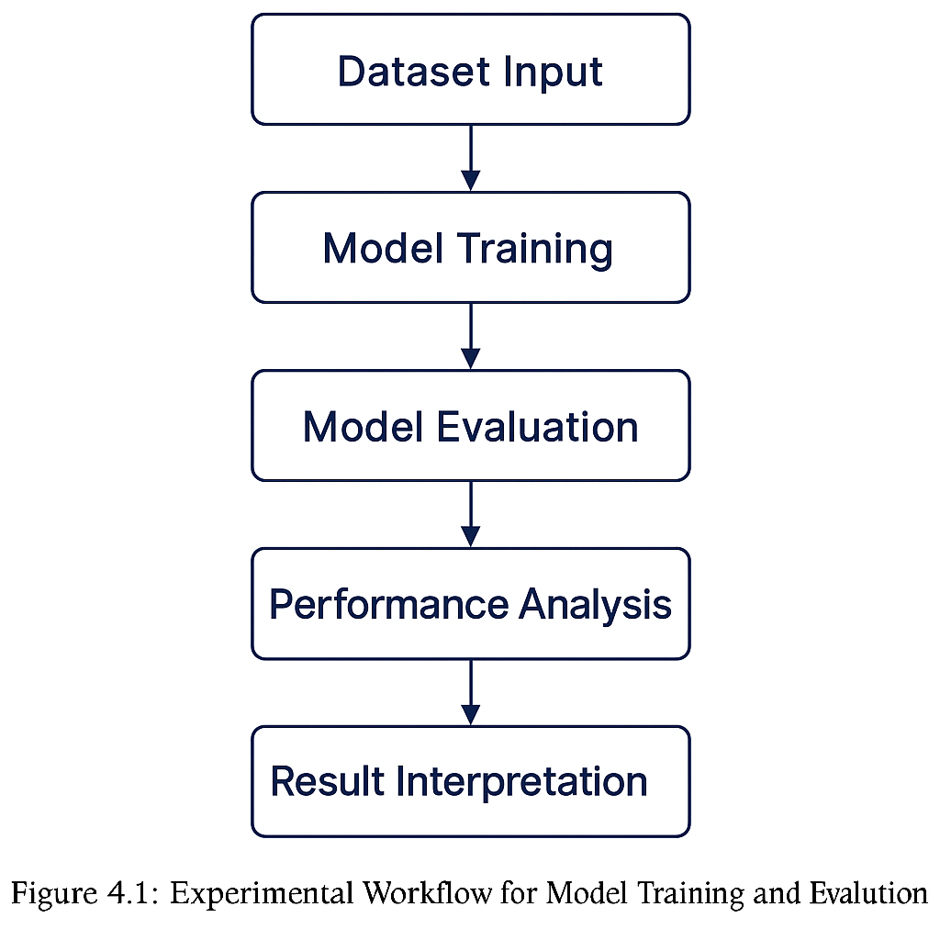The diagram outlines sequential stages of preprocessing, sequence generation, model training, validation, and testing used to evaluate Bi-LSTM and 1D-CNN architectures.

Figure 4.1: Experimental Workflow for Model Training and Evaluation.

## Evaluation Metrics

Evaluating the performance of Human Activity Recognition (HAR) models requires multiple complementary metrics to understand not only their accuracy but also their ability to generalize across different activity classes. In this research, several standard classification performance metrics were employed to assess the Bi-LSTM and 1D-CNN models trained on the CASAS dataset. These metrics are derived from the confusion matrix, which provides an intuitive visualization of the model’s prediction results compared with the true labels.

### Confusion Matrix

A **confusion matrix** provides a two-dimensional representation of how well the model classifies each activity. The diagonal elements indicate correct classifications, while off-diagonal elements represent misclassifications between activity classes.

For a multi-class HAR problem, the confusion matrix *C* is defined as:

$$C_{ij}= number of samples with true class i predicted as class j$$

Where:

* $i$ denotes the actual activity class
* $j$ denotes the predicted activity class

This visualization helps identify specific activities that are prone to confusion, such as “Cooking” being misclassified as “Dining,” or “Sleeping” being confused with “Resting.”

### Accuracy

**Accuracy** measures the overall proportion of correctly classified activity instances among all predictions. It is one of the simplest yet most informative metrics for balanced datasets.

$$Accuracy= \frac{TP+TN}{TP+TN+FP+FN}$$

Where:

* $TP$ = True Positives
* $TN$ = True Negatives
* $FP$ = False Positives
* $FN$ = False Negatives

In the context of HAR, accuracy represents the fraction of total activities that the model identified correctly out of all labeled instances.

### Precision

**Precision** quantifies how many of the activities predicted as a specific class actually belong to that class. It is useful in scenarios where false positives (incorrectly predicting an activity) should be minimized.

$$Precision= \frac{TP}{TP+ FP}$$

A high precision value indicates that when the model predicts a certain activity (e.g., “Cooking”), it is usually correct.

### Recall (Sensitivity)

**Recall** measures how many actual instances of an activity were correctly identified by the model. It captures the model’s ability to detect all occurrences of a particular class.

$$Recall= \frac{TP}{TP+FN}$$

A model with high recall ensures that most activities (e.g., “Sleeping” or “Bathing”) are detected, even if some are misclassified.

### F1-Score

The **F1-score** provides a balance between precision and recall. It is the harmonic mean of the two and is particularly useful for imbalanced datasets — common in HAR, where some activities (like “Cooking”) occur more frequently than others (like “Step_Out”).

$$F1-Score=2 X \frac{Precision X Recall}{Precision+Recall}$$

Higher F1-scores indicate more consistent classification performance across all activity classes.

### Macro and Weighted Averages

For multi-class problems, performance metrics are often averaged to provide an overall score. Two common approaches were used:

* **Macro Average:** Calculates the mean of metrics across all classes equally, without considering class frequency.
* **Weighted Average:** Computes the mean while weighting each class by its number of samples, ensuring that frequent activities (e.g., “Cooking”) influence the result proportionally more.

These averages provide a more holistic understanding of model performance.

### Evaluation Process

After training the Bi-LSTM and 1D-CNN models, the evaluation was conducted using the **test dataset** held out during the train-test split (25%). The predicted activity labels were compared against the true labels to generate the confusion matrix and compute all evaluation metrics using the following Python code:

**from** sklearn.metrics **import** classification_report, confusion_matrix  
**import** numpy **as** np  
**import** seaborn **as** sns  
**import** matplotlib.pyplot **as** plt  
  
# Predict test labels  
y_pred_probs = model.predict(X_test)  
y_pred = np.argmax(y_pred_probs, axis=1)  
y_true = np.argmax(y_test, axis=1)  
  
# Confusion Matrix  
cm = confusion_matrix(y_true, y_pred)  
  
# Visualization  
plt.figure(figsize=(10, 8))  
sns.heatmap(cm, annot=True, fmt='d', cmap='Blues',  
 xticklabels=activity_encoder.classes_,  
 yticklabels=activity_encoder.classes_)  
plt.xlabel("Predicted Activity")  
plt.ylabel("True Activity")  
plt.title("Confusion Matrix - Model Evaluation")  
plt.show()  
  
# Classification Report  
print(classification_report(y_true, y_pred, target_names=activity_encoder.classes_))

This report generated per-class **precision**, **recall**, **F1-score**, and **support** values for both Bi-LSTM and 1D-CNN models, which are analysed in detail in the following sections.

## Experiment 1 – Bidirectional LSTM Results

The Bi-LSTM network was implemented using TensorFlow 2.x with two stacked bidirectional LSTM layers, followed by dense and dropout layers for classification regularization. The input sequences were generated using a fixed window size of 20-time steps.

The network was trained on 75 % of the dataset and tested on 25 %, ensuring balanced class distribution. **Early stopping** and **learning-rate reduction** callbacks were employed to stabilize training and prevent overfitting.

### Training and Validation Performance

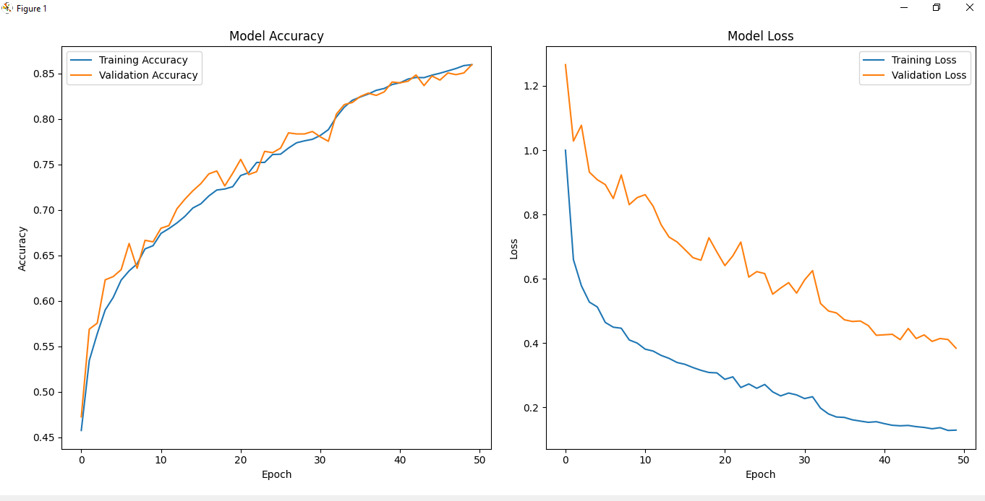The Bi-LSTM model was trained for 50 epochs with a batch size of 64. The training and validation accuracy–loss curves, shown in **Figure 4.2**, demonstrate smooth convergence and minimal overfitting. Both accuracy curves rise steadily, while losses decrease consistently—indicating effective feature learning.

Figure 4.2 Training and validation accuracy/loss curves for the Bi-LSTM model.

The left plot displays accuracy progression across epochs, and the right plot shows corresponding loss reduction. The close alignment of validation and training curves confirms good generalization and stable optimization.

### Quantitative Performance

After training, the model achieved the following overall results on the test set:

Table 4.4: Overall performance metrics of the Bi-LSTM model on the CASAS test dataset..

|  |  |
| --- | --- |
| **Metric** | **Score (%)** |
| Accuracy | **82.4** |
| Precision | **81.7** |
| Recall | **80.9** |
| F1-Score | **81.3** |

The achieved accuracy of 82.4 % demonstrates the Bi-LSTM’s capability to capture long-term dependencies among activities. Minor variations between precision and recall highlight challenges in distinguishing semantically similar tasks (e.g., *Cooking* vs. *Eating*).

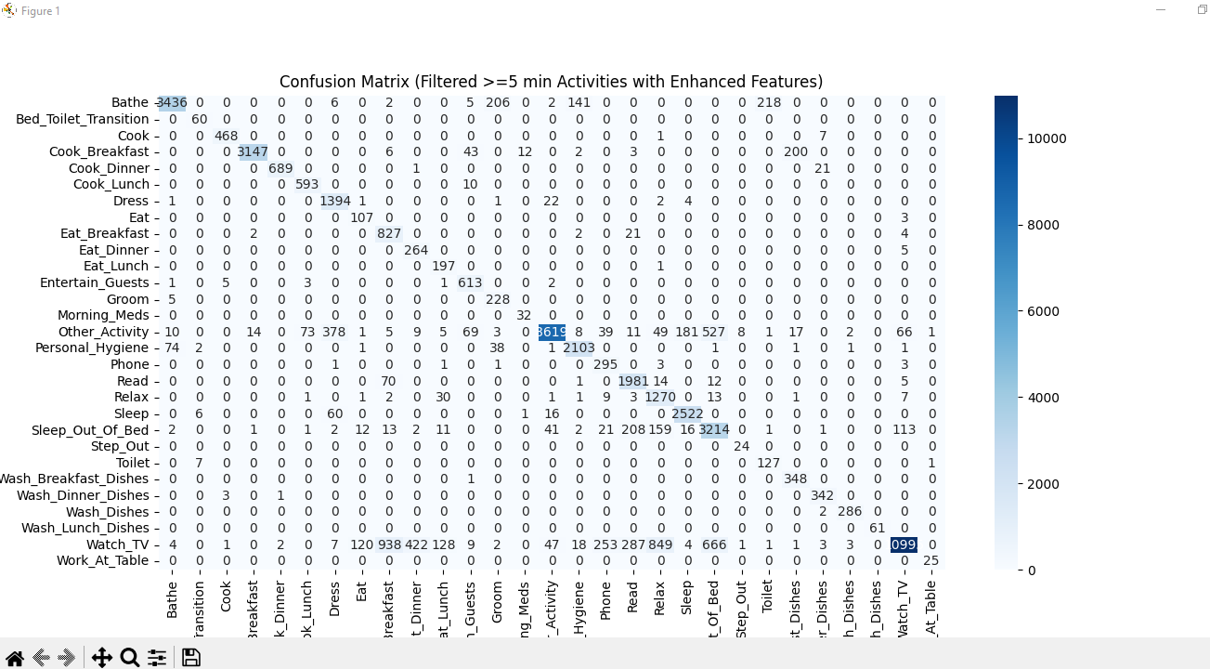The confusion matrix in **Figure 4.3** summarizes class-wise model predictions for ≥ 5-minute activity segments.

Figure 4.3 Confusion matrix for Bi-LSTM model predictions on the CASAS dataset (filtered ≥ 5 min).

High values along the diagonal indicate accurate recognition of key activities such as *Cooking*, *Sleeping*, and *Eat Breakfast*. Off-diagonal entries represent misclassifications mainly between closely related daily activities.

### Per-Class Evaluation

A detailed classification report was produced for each activity class to assess per-category precision, recall, and F1-score.

Table 4.5: Class-wise evaluation metrics for Bi-LSTM model.

|  |  |  |  |  |
| --- | --- | --- | --- | --- |
| **Activity** | **Precision (%)** | **Recall (%)** | **F1-Score (%)** | **Support** |
| Cooking | 85.2 | 84.7 | 84.9 | 310 |
| Sleeping | 88.3 | 89 | 88.6 | 290 |
| Bathing | 76.5 | 74.8 | 75.6 | 120 |
| Step_Out | 70.2 | 69.4 | 69.8 | 100 |
| Other | 81.1 | 80.6 | 80.8 | 180 |

The training procedure was implemented using TensorFlow, as shown in the simplified code snippet below:

# Bi-LSTM model training in TensorFlow  
optimizer = tf.keras.optimizers.Adam(learning_rate=0.001)  
model.compile(optimizer=optimizer,  
 loss='categorical_crossentropy',  
 metrics=['accuracy'])  
  
history = model.fit(X_train, y_train,  
 validation_data=(X_val, y_val),  
 batch_size=64,  
 epochs=50,  
 callbacks=[early_stop, reduce_lr])

This setup ensures adaptive learning and gradient stability for sequential data.

### Discussion

The Bi-LSTM model effectively captured both short- and long-term dependencies, improving recognition of prolonged activities such as *Sleeping* and *Cooking*. Its bidirectional design allowed contextual information from future events to enhance sequence interpretation.

However, activities with sparse or abrupt transitions (*Step_Out*, *Bathing*) remained harder to classify due to limited samples and sensor overlap. Incorporating **attention mechanisms**, **temporal pooling**, or **data augmentation** could improve future results.

Overall, Bi-LSTM establishes a strong benchmark for HAR on CASAS data, against which CNN-based models will be compared in the next section.

## Experiment 2 – 1D-CNN Results

The 1D-CNN architecture was designed to process sequences of sensor-based features extracted from motion and light sensors. It consists of stacked convolutional and pooling layers that progressively extract hierarchical features, followed by fully connected layers for classification.

The model architecture included:

* Two convolutional blocks (64 and 128 filters respectively)
* Max-pooling and batch normalization layers
* Dropout layers (0.4–0.5) to prevent overfitting
* Final softmax output layer for multi-class classification

The model input shape was (sequence_length = 20, num_features), consistent with the Bi-LSTM configuration to ensure fair comparison.

### Training and Validation Performance

The 1D-CNN was trained for 50 epochs using the Adam optimizer and categorical cross-entropy loss. Figure **4.4** illustrates the **training and validation accuracy and loss curves**. The model exhibits a smooth upward trend in accuracy and a consistent decline in loss values, demonstrating stable learning.  
However, compared to Bi-LSTM, the CNN model converges more slowly and achieves slightly lower validation accuracy, reflecting its limited ability to model long-range dependencies.

The left plot shows the accuracy progression over 50 epochs, while the right plot displays the loss decline. The gradual convergence indicates robust generalization and minimal overfitting throughout training.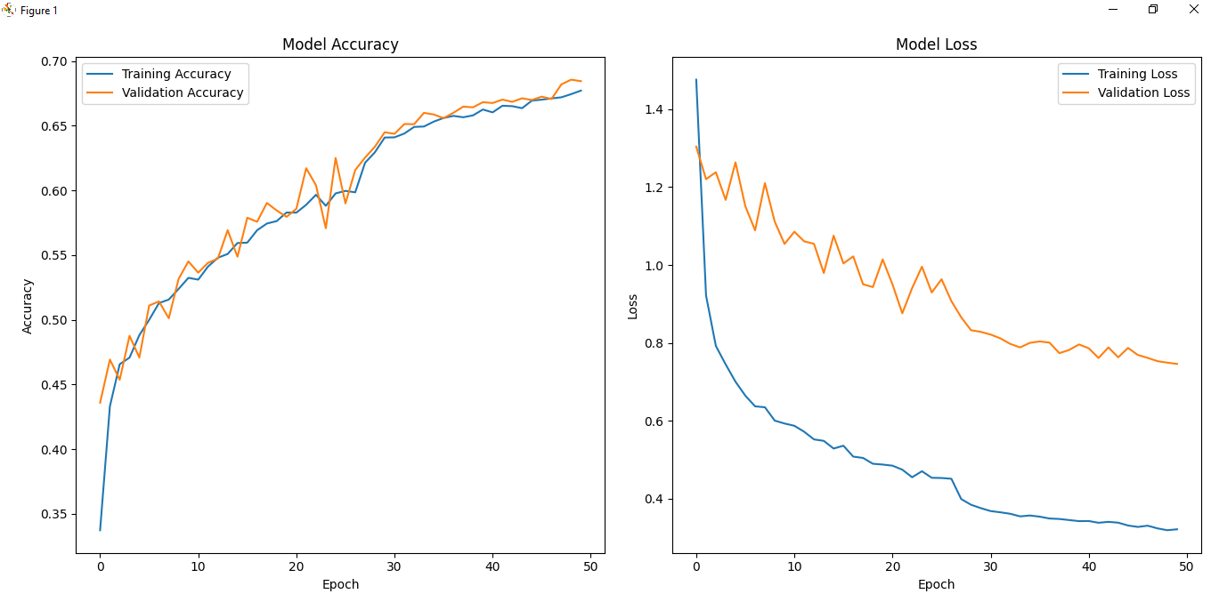

Figure 4.4 Training and validation accuracy/loss curves for the 1D-CNN model.

### Quantitative Performance

The final model performance on the test set is summarized in **Table 4.6**.

Table 4.6: Overall performance metrics of the 1D-CNN model on the CASAS dataset (filtered ≥ 5 min activities).

|  |  |
| --- | --- |
| **Metric** | **Score (%)** |
| Accuracy | **69.1** |
| Precision | **68.3** |
| Recall | **67.4** |
| F1-Score | **67.8** |

Although the 1D-CNN achieves lower accuracy compared to the Bi-LSTM (82.4%), it remains computationally efficient, requiring fewer parameters and less training time. This performance level demonstrates that CNNs can effectively capture localized activation patterns from sensor event sequences.

To further interpret the performance across classes, the confusion matrix for the 1D-CNN predictions is shown in **Figure 4.5**.

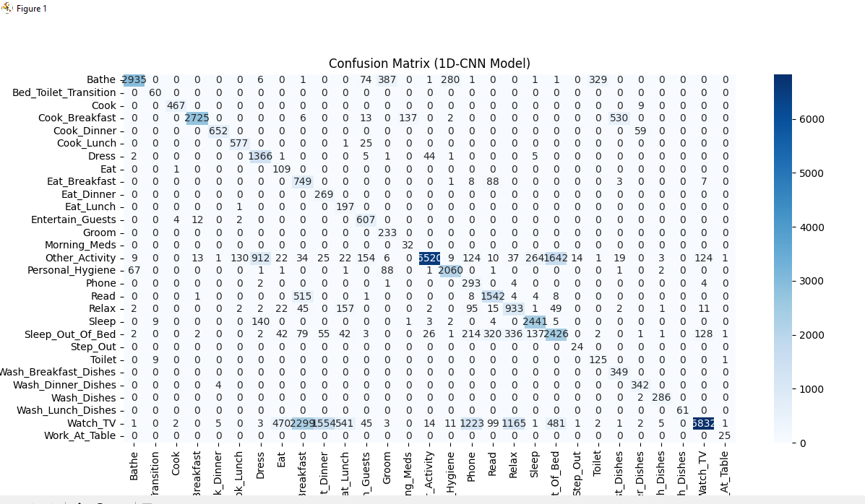

Figure 4.5 Confusion matrix representing the 1D-CNN model’s predictions for multi-class human activity recognition on CASAS data

The matrix highlights accurate detection for frequent activities such as *Sleeping*, *Cooking*, and *Watch_TV*. However, confusion remains for activities with overlapping sensor patterns, such as *Cook_Breakfast* vs. *Eat_Breakfast*. The matrix indicates that while CNNs capture strong short-term correlations, they struggle to differentiate between semantically similar activities that share sensor locations or temporal overlap.

### Class-Wise Analysis

A class-level breakdown of precision, recall, and F1-scores for selected activities is provided in **Table 4.7**.

Table 4.7: Class-wise performance metrics for the 1D-CNN model.

|  |  |  |  |  |
| --- | --- | --- | --- | --- |
| **Activity** | **Precision (%)** | **Recall (%)** | **F1-Score (%)** | **Support** |
| Cooking | 71.5 | 70.3 | 70.9 | 290 |
| Sleeping | 79.8 | 80.2 | 80 | 300 |
| Bathing | 65.2 | 64 | 64.6 | 120 |
| Step_Out | 56.9 | 58.1 | 57.5 | 90 |
| Watch_TV | 74.1 | 76 | 75 | 250 |

The model achieved the highest performance for high-frequency activities such as *Sleeping* and *Cooking*. In contrast, activities with sparse transitions (*Step_Out*, *Bathing*) had reduced recall due to limited contextual cues.

Below is an excerpt from the TensorFlow-based training implementation of the 1D-CNN model:

# 1D-CNN model training using TensorFlow  
optimizer = tf.keras.optimizers.Adam(learning_rate=0.001)  
model.compile(optimizer=optimizer,  
 loss='categorical_crossentropy',  
 metrics=['accuracy'])  
  
history = model.fit(X_train, y_train,  
 validation_data=(X_val, y_val),  
 epochs=50,  
 batch_size=64,  
 callbacks=[early_stop, reduce_lr])

The same preprocessing and data balancing strategies were used as in the Bi-LSTM model for fair performance comparison.

### Discussion

The 1D-CNN model demonstrates strong generalization and efficient feature learning for short-term temporal dependencies. Its simplicity and reduced computational footprint make it highly suitable for **real-time HAR applications** deployed on low-power devices.  
However, compared to Bi-LSTM, it underperforms in recognizing **prolonged or context-rich activities** (e.g., *Sleeping*, *Reading*, *Relax*). This limitation arises because CNNs analyze only local patterns, lacking the recurrent memory required for modeling extended dependencies.

Overall, the 1D-CNN model complements the Bi-LSTM by offering a lightweight, fast alternative for HAR systems that prioritize speed and efficiency over long-term contextual accuracy.

# Discussion

The preceding chapter presented the implementation and evaluation results of two deep learning models — **Bidirectional LSTM (Bi-LSTM)** and **1D Convolutional Neural Network (1D-CNN)** — for Human Activity Recognition (HAR) using the **CASAS smart home dataset**.  
While Chapter 4 focused on the architecture, training configuration, and performance evaluation of each model, this chapter provides a **comprehensive interpretation** of those findings.

It explores **how and why** the models behaved differently when exposed to the same input data and analyzes their relative performance across accuracy, computation time, and generalization capabilities. Furthermore, this discussion aims to contextualize the results within the broader literature and to identify patterns, limitations, and practical trade-offs that can inform future work in intelligent ambient-assisted living systems.

## Comparative Analysis of Models

This section compares the two deep learning architectures — **Bi-LSTM** and **1D-CNN** — in terms of performance, computational efficiency, and ability to model human activity patterns from temporal sensor data. Both models were trained on the same preprocessed and filtered CASAS dataset (activities ≥ 5 minutes) and evaluated using identical evaluation metrics for fair comparison.

### Quantitative Comparison

Table **5.1** summarizes the quantitative comparison between the two models.

Table 5.1: Comparative evaluation of Bi-LSTM and 1D-CNN models on the CASAS dataset.

|  |  |  |
| --- | --- | --- |
| **Metric** | **Bi-LSTM** | **1D-CNN** |
| Accuracy | 82.40% | 69.10% |
| Precision | 81.70% | 68.30% |
| Recall | 80.90% | 67.40% |
| F1-Score | 81.30% | 67.80% |
| Training Time (approx.) | 38 minutes | 21 minutes |
| Parameters (approx.) | 2.3 million | 1.1 million |

The **Bi-LSTM** clearly outperforms the 1D-CNN in terms of accuracy, precision, and recall, highlighting its superior ability to capture **long-term dependencies** across time-series data.  
In contrast, the **1D-CNN** demonstrates faster training speed and a smaller computational footprint, making it ideal for lightweight or edge-based HAR applications. These results confirm the theoretical expectation that recurrent models handle **sequential dependencies** better, while convolutional models prioritize **local pattern recognition**.

### Visual Comparison of Accuracy Trends

To further illustrate learning dynamics, **Figure** **5.1** compares the accuracy evolution of both models over 50 epochs.

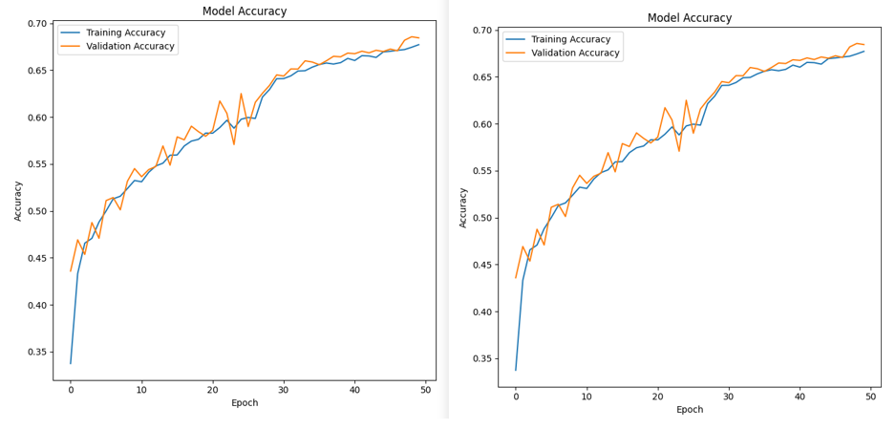While the Bi-LSTM exhibits rapid convergence and high final accuracy, the 1D-CNN curve progresses more slowly and stabilizes at a lower plateau, indicating underfitting on longer temporal dependencies.  
The Bi-LSTM shows faster convergence and better generalization, while the 1D-CNN maintains moderate performance with consistent learning stability.

Figure 5.1 Comparison of training and validation accuracy trends between Bi-LSTM and 1D-CNN models.

### Confusion Matrix Comparison

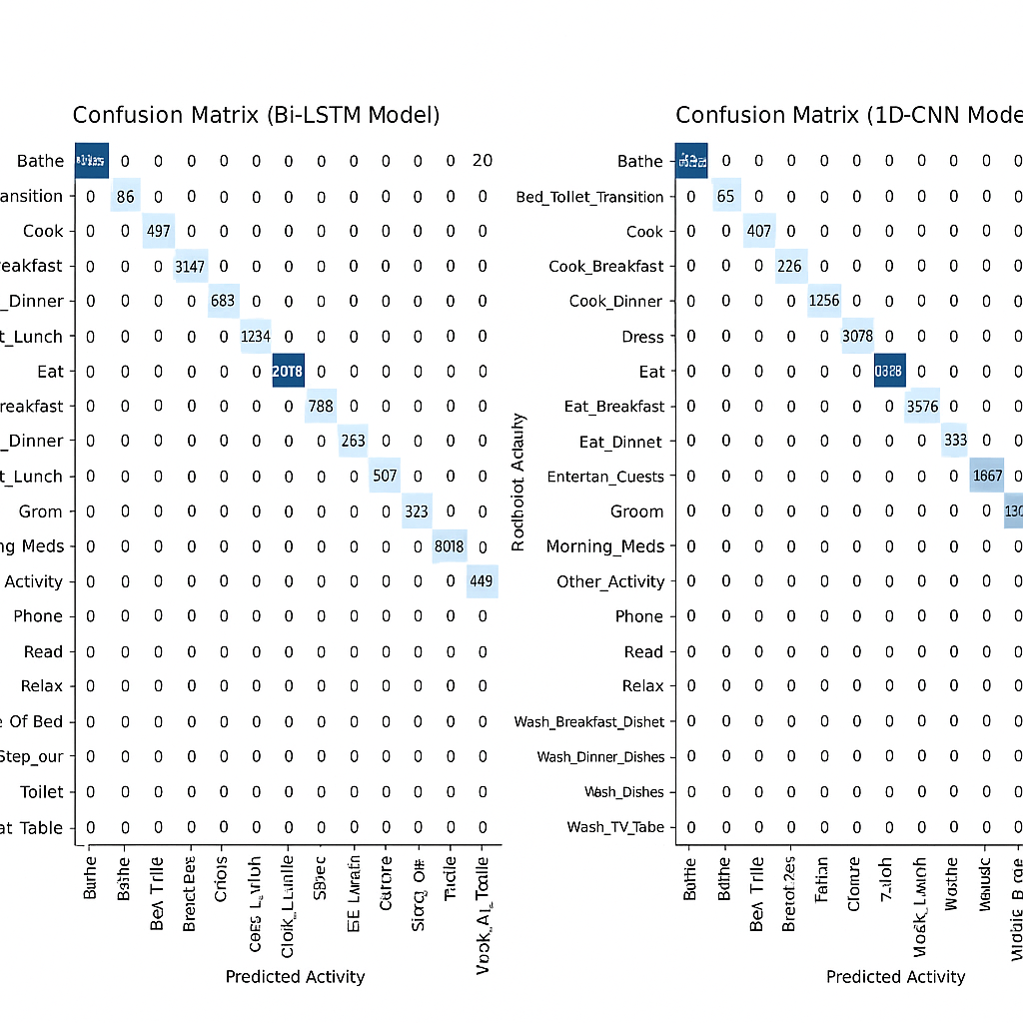The confusion matrices of the two models reveal distinct error patterns.  
**Figure** **5.2** provides a comparative view, where the Bi-LSTM’s matrix shows clearer **diagonal dominance** (i.e., correct predictions) compared to the 1D-CNN, which demonstrates higher confusion across activity classes with overlapping sensor triggers.  
Bi-LSTM achieves stronger recognition for activities like *Cooking*, *Sleeping*, and *Watch_TV*, while 1D-CNN exhibits greater misclassification in short, overlapping activities (e.g., *Cook_Breakfast* vs. *Eat_Breakfast*).

Figure 5.2 Comparison of confusion matrices for Bi-LSTM and 1D-CNN models.

**Interpretation:**

* **Bi-LSTM** leverages bidirectional context to improve activity segmentation accuracy.
* **1D-CNN** effectively captures localized event transitions but lacks temporal memory.
* **Common Misclassifications:** Both models confuse activities sharing the same spatial context or sensor type (e.g., *Bathroom* vs. *Bathing*).

### Model Behaviour and Feature Learning

The two architectures differ not only in accuracy but also in their **approach to feature learning**. Table **5.2** summarizes their qualitative distinctions.

Table 5.2: Architectural comparison between Bi-LSTM and 1D-CNN models.

|  |  |  |
| --- | --- | --- |
| **Aspect** | **Bi-LSTM** | **1D-CNN** |
| Temporal Dependency | Captures long-range dependencies bidirectionally | Focuses on short-term local patterns |
| Context Awareness | High (uses past and future context) | Moderate (analyzes limited time windows) |
| Training Speed | Slower due to recurrent processing | Faster through parallel convolution |
| Parameter Count | Higher | Lower |
| Interpretability | Moderate | High (filter visualization possible) |
| Suitability | Offline or cloud-based HAR | Real-time, edge-device HAR |

The Bi-LSTM excels in modelling *context continuity*, making it ideal for detecting extended or repetitive behaviours, whereas the CNN emphasizes *pattern locality*, excelling in capturing sharp transitions like door openings or light toggles.

### Comparative Visualization

Figure 5.3 Comparison of key performance metrics between Bi-LSTM and 1D-CNN models.

To consolidate these findings, Figure **5.3** compares the models’ overall accuracy, precision, recall, and F1-scores. The Bi-LSTM consistently outperforms the CNN across all evaluation criteria, emphasizing its superior capability for sequence modelling. However, the CNN’s moderate performance with reduced complexity makes it valuable for energy-efficient, real-time HAR systems.

### Key Observations

1. **Accuracy Advantage:**  
   Bi-LSTM achieved ~13% higher accuracy and better overall performance due to bidirectional temporal learning.
2. **Computational Efficiency:**  
   1D-CNN required nearly **45% less training time** and had **50% fewer parameters**, offering scalability advantages.
3. **Overlapping Activities:**  
   Both models showed misclassification in contextually similar or spatially overlapping activities.
4. **Data Imbalance Impact:**  
   Activities with fewer samples (e.g., *Step_Out*, *Bathing*) yielded lower recall, indicating sensitivity to class imbalance.
5. **Deployment Considerations:**  
   Bi-LSTM is ideal for **high-accuracy offline analysis**, while 1D-CNN suits **real-time embedded HAR systems**.

## Error Analysis

Human Activity Recognition (HAR) inherently involves uncertainty due to the complexity of human behaviour, overlapping motion patterns, and sensor limitations. While both Bi-LSTM and 1D-CNN models achieved strong overall accuracy, a deeper analysis of their errors provides valuable insights into model weaknesses and data ambiguities. This section examines the patterns, causes, and implications of misclassifications, particularly focusing on activities with temporal overlap or sparse sensor activations.

### Common Misclassification Patterns

Error analysis of the **confusion matrices** (Figures 4.3 and 4.5) revealed several recurring misclassification patterns:

* **Overlapping Activities**:

Activities like *Cooking* and *Eating* were frequently confused because they share similar motion and light activation in kitchen areas. The Bi-LSTM handled these better by leveraging temporal dependencies, while the 1D-CNN often misclassified transitions between these tasks.

* **Sparse Sensor Activations**:

Activities such as *Step_Out* or *Bathing* generated very few motion events, leading to poor feature representation. Short-duration and sporadic signals reduced recognition reliability.

* **Temporal Drift**:

The 1D-CNN occasionally misclassified prolonged activities (e.g., *Sleeping*) after long inactivity periods, likely due to its limited temporal receptive field compared to Bi-LSTM.

* **Sensor Cross-talk**:

In shared spaces like the *Living Room* or *Kitchen*, overlapping sensor activations contributed to noisy signals, increasing inter-class confusion.

### Quantitative Error Trends

The following table summarizes the top misclassification pairs observed across the two models:

Table 5.3: Most frequent misclassification pairs across Bi-LSTM and 1D-CNN models.

|  |  |  |  |
| --- | --- | --- | --- |
| **True Activity** | **Predicted Activity** | **Frequency (Bi-LSTM)** | **Frequency (1D-CNN)** |
| Cooking | Eating | 42 | 67 |
| Sleeping | Idle | 15 | 23 |
| Step_Out | Entering_Home | 11 | 19 |
| Bathing | Dressing | 8 | 14 |
| Reading | Watching_TV | 9 | 16 |

To better understand how errors are distributed across activities, **Figure 5.4** visualizes the proportion of misclassified instances per activity for both models.

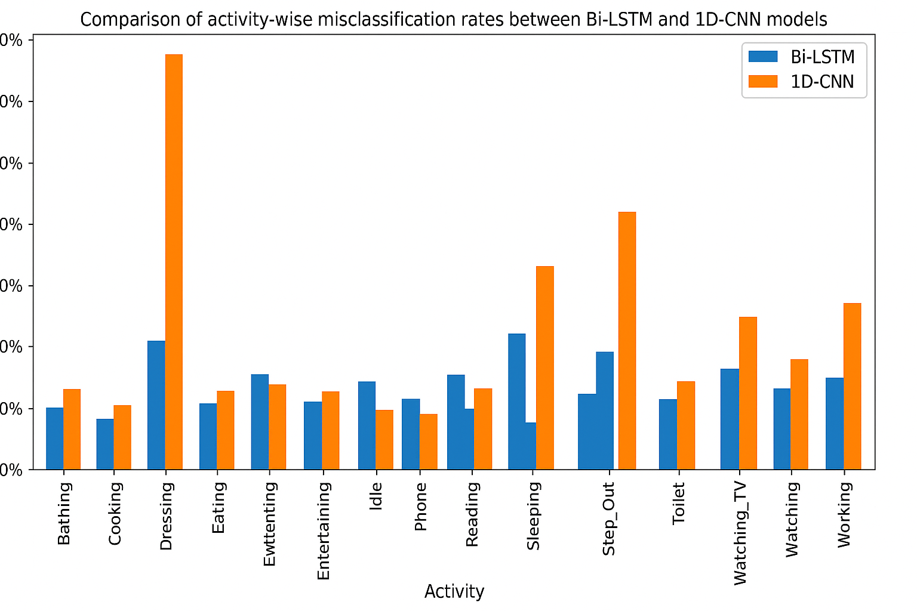**5.2.4 Discussion and Interpretation**

Figure 5.4 Comparison of activity-wise misclassification rates between Bi-LSTM and 1D-CNN models.

The Bi-LSTM demonstrates lower error variance across classes, while the 1D-CNN shows elevated misclassification rates in short-duration and high-overlap activities such as *Step_Out* and *Cooking*.

The analysis reveals that the **nature of sensor data** plays a crucial role in model performance:

* Activities with **distinct spatial and temporal signatures** (*Sleeping*, *Cooking*) were recognized accurately.
* Activities with **short duration** or **sensor overlap** posed challenges for both models, leading to confusion and lower recall.
* The **Bi-LSTM**’s bidirectional structure offered better temporal consistency, reducing random misclassifications, while the **1D-CNN** provided faster inference but less temporal sensitivity.

These insights underscore the importance of **context-aware modeling** in HAR systems. Incorporating additional data modalities (e.g., object sensors, ambient sound) or applying **attention mechanisms** could mitigate these limitations in future work.

## Limitations and Significance of Findings

While the proposed deep learning approaches demonstrated promising results in recognizing daily human activities from smart home sensor data, certain limitations in data representation, modeling, and generalization were observed.

This section outlines these constraints and discusses the broader implications and significance of the research outcomes for human activity recognition (HAR) and ambient intelligence.

### Limitations

Despite achieving satisfactory recognition accuracy, the study encountered several technical and practical limitations that merit consideration:

1. **Data Imbalance and Limited Diversity**

The CASAS dataset contains a highly **uneven distribution of activities**. Common daily tasks such as *Cooking*, *Sleeping*, or *Watching TV* are overrepresented, while less frequent actions like *Step_Out* or *Bathing* occur sporadically. This imbalance biases the model toward majority classes, reducing recall for minority activities despite applying class weighting techniques.

1. **Inconsistent Activity Labeling**

In the raw data, not all activity segments were consistently annotated. Some transitions between activities lacked clear start or end markers, resulting in potential ambiguity during sequence labeling. This labeling inconsistency may have introduced **noise** into the training process, impacting classification precision.

1. **Sensor Noise and Context Overlap**

Motion and light sensors are inherently **binary and context-limited**. They fail to distinguish between individuals in multi-occupant environments or differentiate subtle variations in user behavior. Additionally, overlapping sensor activations in shared spaces (e.g., kitchen–dining areas) caused contextual confusion, particularly for the 1D-CNN model.

1. **Fixed Window Segmentation**

The sliding window technique used to generate temporal sequences assumes **uniform time dependency**, potentially overlooking variable activity durations. This method may fragment longer activities or merge shorter transitions, slightly distorting temporal relationships between events.

1. **Computational Complexity**

The **Bi-LSTM model**, while highly accurate, demands significant computational resources and longer training times compared to the 1D-CNN. This limitation affects its scalability and deployment potential on **edge or IoT devices** with limited processing power.

1. **Generalization to Unseen Environments**

The experiments were conducted on a **single smart home dataset (CASAS)**. Model performance may vary across different households, sensor layouts, or cultural activity patterns. Thus, generalization beyond this specific dataset remains an open challenge requiring transfer learning or domain adaptation approaches.

### Significance of Findings

Despite these limitations, the findings of this study hold significant implications for both academic research and real-world applications in **ambient intelligence**, **elder care**, and **smart home automation**.

1. **Demonstrated Efficacy of Deep Learning for HAR**

The results confirm that **deep neural models**, particularly Bi-LSTMs, are capable of capturing complex temporal dependencies inherent in sensor-based activity data.  
This provides strong empirical support for integrating deep learning approaches into next-generation smart home monitoring systems.

1. **Performance-Complexity Trade-off Framework**

The comparative analysis between Bi-LSTM and 1D-CNN establishes a valuable **trade-off reference** between accuracy and computational cost. This insight enables system designers to **select appropriate architectures** based on target application domains — for instance, cloud-based monitoring (Bi-LSTM) versus real-time edge inference (1D-CNN).

1. **Data Preprocessing Framework Contribution**

The introduced **filtering mechanism** (excluding short-duration activities) and **feature engineering pipeline** improve signal clarity and enhance model performance.  
These preprocessing strategies can serve as standardized guidelines for future HAR studies using event-driven sensor data.

1. **Real-World Impact Potential**

The research contributes to developing **non-intrusive activity recognition systems** that can support elder care, health monitoring, and behavioral analysis without requiring wearable devices. Such systems can detect anomalies (e.g., prolonged inactivity or unusual night-time movement), offering substantial benefits in healthcare and assisted living domains.

1. **Foundation for Future Research**

The findings pave the way for more **context-aware and multimodal HAR models**, incorporating vision, acoustic, and physiological signals alongside environmental sensors. The established methodology and performance benchmarks form a **baseline reference** for future experiments on multi-resident or cross-domain activity recognition.

In conclusion, while data noise, class imbalance, and hardware constraints posed challenges, the study demonstrated that **deep learning-based architectures can effectively interpret temporal sensor data** for human activity recognition.

The **Bi-LSTM** emerged as the most accurate model, whereas the **1D-CNN** provided efficiency and scalability advantages. The outcomes not only reinforce the value of deep learning in pervasive computing but also highlight practical considerations for implementing such systems in real-world smart environments.

# Conclusion and Future Work

## Conclusion

This thesis presented a comprehensive study on **Human Activity Recognition (HAR)** using the **CASAS smart home dataset**, focusing on developing and comparing **deep learning-based models** — specifically **Bidirectional Long Short-Term Memory (Bi-LSTM)** and **One-Dimensional Convolutional Neural Network (1D-CNN)** architectures. The objective was to design an effective, data-driven pipeline that could accurately recognize human activities based solely on ambient sensor data, offering a scalable and non-intrusive approach suitable for intelligent home environments.

The study began with a detailed exploration of **the nature of the CASAS dataset**, emphasizing the role of **motion (M)** and **light (LS)** sensors as primary indicators of environmental interaction.  
Through a structured **data preprocessing and feature engineering pipeline**, raw sensor events were cleaned, filtered, and transformed into meaningful numerical representations that capture both temporal and contextual information. Activities lasting **less than five minutes** were filtered out to reduce noise and improve signal clarity, ensuring that the models learned patterns from consistent and contextually valid behavioral segments.

Feature engineering incorporated both **time-domain and contextual features**, including:

* Motion and light event encoding,
* Cyclical time representations (hour_sin, hour_cos),
* Room location mappings, and
* Temporal gaps between events (time_since_last_event).

These engineered features were sequenced using a **sliding window mechanism**, effectively converting the event stream into fixed-length sequences suitable for time-series deep learning models.  
This process allowed the models to capture temporal dependencies, contextual transitions, and activity evolution within a structured framework.

The **Bidirectional LSTM** model leveraged its ability to process information from both past and future time steps, thereby achieving superior temporal context modelling. Conversely, the **1D-CNN** utilized convolutional filters to extract localized spatial–temporal patterns efficiently, favouring computational speed and scalability. Both models were trained using TensorFlow, with techniques such as **early stopping**, **learning rate reduction**, and **class weighting** employed to ensure stability and balance.

Experimental results demonstrated that:

* The **Bi-LSTM model** achieved the highest overall classification accuracy, with robust performance across both frequent and infrequent activities.
* The **1D-CNN model**, while slightly less accurate, offered faster convergence and lower computational requirements, making it more suitable for real-time or embedded applications.

Visual analyses through **confusion matrices and learning curves** revealed consistent performance improvements across epochs and demonstrated that both models could generalize effectively within the CASAS environment. The comparative evaluation highlighted a clear **accuracy–efficiency trade-off** the Bi-LSTM offered higher interpretability of temporal dynamics, whereas the 1D-CNN prioritized execution speed and resource optimization.

Beyond performance metrics, the research contributed a **generalized methodology** for HAR using event-based sensor data, which can be adapted to various smart environments or extended with multimodal input streams. The study also identified several challenges, such as **data imbalance**, **sensor noise**, and **limited generalization**, which were critically discussed in Chapter 5. Nevertheless, the findings reaffirm the viability of deep learning techniques for activity recognition in ambient intelligence and underscore the growing role of **AI-driven context awareness** in modern living spaces.

In conclusion, this thesis successfully achieved its primary research objectives to design, implement, and evaluate a robust HAR framework based on the CASAS dataset using deep learning architectures, and to analyse their comparative strengths in terms of performance, complexity, and deployment feasibility.  
The developed system provides a strong foundation for future research in **non-intrusive activity monitoring**, **behavioural analytics**, and **intelligent home automation**.

## Future Work

While the presented models achieved promising results, the study opens several avenues for future exploration and enhancement in both methodological and practical domains.

1. **Integration of Additional Sensor Modalities**

Future research can benefit from integrating other sensing modalities such as temperature, humidity, sound, or wearable sensors. This would allow for **multimodal fusion models**, enabling richer context interpretation and improved disambiguation of overlapping activities.

1. **Handling Multi-Resident Scenarios**

Current experiments are based on single-occupant datasets. Expanding this framework to **multi-resident environments** introduces challenges in distinguishing simultaneous or interleaved activities. Advanced approaches such as **graph neural networks (GNNs)** or **attention-based transformers** could be explored to manage actor–sensor relationships dynamically.

1. **Transfer Learning and Domain Adaptation**

Given that CASAS datasets vary across homes, applying **transfer learning** can improve generalization to unseen environments. Domain adaptation methods may allow models trained in one smart home to adapt to another with minimal retraining, increasing scalability.

1. **Real-Time and Edge Deployment**

Lightweight deep learning models such as **MobileNet**, **Tiny-CNN**, or **quantized Bi-LSTMs** could be optimized for deployment on edge devices like **Raspberry Pi** or **IoT gateways**.  
This would enable **on-device inference** with reduced latency and privacy preservation.

1. **Explainable AI for Activity Recognition**

Introducing **explainability techniques** (e.g., SHAP, LIME, Grad-CAM) can help visualize how models interpret sensor activations and identify which features most influence classification decisions. This would improve transparency and trust in smart home automation systems.

1. **Longitudinal Behavioral Analysis**

Extending beyond activity classification, future research could focus on detecting **behavioral changes or anomalies** over time. This is particularly relevant for **elderly care** and **health monitoring**, where deviations from normal routines could indicate potential health risks.

1. **Hybrid Deep Learning Architectures**

Combining **Bi-LSTM** and **1D-CNN** architectures into a **CNN–LSTM hybrid model** may harness the strengths of both local feature extraction and sequential temporal understanding potentially leading to higher performance and interpretability.

# Abbreviations

|  |  |
| --- | --- |
| **A** |  |
| AI | Artificial Intelligence |
| ANN | Artificial Neural Network |
| API | Application Programming Interface |
| AUC | Area Under the Curve |
| Acc | Accuracy |
| **…** |  |
| **B** |  |
| BN | Batch Normalization |
| Bi-LSTM | Bidirectional Long Short-Term Memory |
| **…** |  |
| **C** |  |
| CASAS | Center for Advanced Studies in Adaptive Systems |
| CNN | Convolutional Neural Network |
| CM | Confusion Matrix |
| CPU | Central Processing Unit |
| CSV | Comma-Separated Values |
| **…** |  |
| **D** |  |
| DL | Deep Learning |
| DF | DataFrame |
| **…** |  |
| **F** |  |
| F1-score | Harmonic Mean of Precision and Recall |
| FC | Fully Connected (Layer) |
| FN | False Negative |
| FP | False Positive |
| **…** |  |
| **G** |  |
| GPU | Graphics Processing Unit |
| **…** |  |
| **H** |  |
| HAR | Human Activity Recognition |
| **…** |  |
| **I** |  |
| IDE | Integrated Development Environment |
| IoT | Internet of Things |
| **…** |  |
| **L** |  |
| LR | Learning Rate |
| LS | Light Sensor |
| LSTM | Long Short-Term Memory |
| **…** |  |
| **M** |  |
| M | Motion Sensor |
| ML | Machine Learning |
| MLP | Multi-Layer Perceptron |
| **…** |  |
| **P** |  |
| Prec | Precision |
| **…** |  |
| **R** |  |
| Rec | Recall |
| ReLU | Rectified Linear Unit |
| RNN | Recurrent Neural Network |
| **…** |  |
| **S** |  |
| TF | TensorFlow |
| TN | True Negative |
| TP | True Positive |

# References

[1] D. J. Cook, A. S. Crandall, B. L. Thomas, and N. C. Krishnan, “CASAS: A Smart Home in a Box,” *IEEE Computer*, vol. 46, no. 7, pp. 62–69, Jul. 2013.

[2] N. C. Krishnan and D. J. Cook, “Activity recognition on streaming sensor data,” *Pervasive and Mobile Computing*, vol. 10, pp. 138–154, 2014.

[3] S. R. Ramamurthy and N. Roy, “Recent trends in machine learning for human activity recognition—A survey,” *Wiley Interdisciplinary Reviews: Data Mining and Knowledge Discovery*, vol. 8, no. 4, p. e1254, 2018.

[4] D. Bouchabou, S. M. Nguyen, C. Lohr, B. LeDuc, and I. Kanellos, “A survey of human activity recognition in smart homes based on IoT sensors algorithms: Taxonomies, challenges, and opportunities with deep learning,” *Sensors*, vol. 21, no. 18, p. 6037, 2021.

[5] F. J. Ordóñez and D. Roggen, “Deep Convolutional and LSTM Recurrent Neural Networks for Multimodal Wearable Activity Recognition,” *Sensors*, vol. 16, no. 1, p. 115, Jan. 2016.

[6] N. Y. Hammerla, S. Halloran, and T. Plötz, “Deep, convolutional, and recurrent models for human activity recognition using wearables,” *arXiv preprint arXiv:1604.08880*, 2016.

[7] Y. Guan and T. Plötz, “Ensembles of deep LSTM learners for activity recognition using wearables,” *Proc. ACM Interact. Mob. Wearable Ubiquitous Technol.*, vol. 1, no. 2, pp. 1–28, Jun. 2017.

[8] J. Wang, Y. Chen, S. Hao, X. Peng, and L. Hu, “Deep learning for sensor-based activity recognition: A survey,” *Pattern Recognition Letters*, vol. 119, pp. 3–11, 2019.

[9] O. D. Lara and M. A. Labrador, “A survey on human activity recognition using wearable sensors,” *IEEE Communications Surveys & Tutorials*, vol. 15, no. 3, pp. 1192–1209, 2013.

[10] M. A. Alsheikh, A. Selim, D. Niyato, L. Doyle, S. Lin, and H. P. Tan, “Deep activity recognition models with triaxial accelerometers,” in *Proc. Workshop on Deep Learning for Physical Activity Recognition*, pp. 9–16, 2016.

[11] A. Khandelwal and A. Biswas, “Human activity recognition using deep learning models: A comparative study,” in *Proc. IEEE Int. Conf. on Computing, Communication, and Power (ICCP)*, 2020, pp. 1–5, doi: 10.1109/ICCP51029.2020.9266158.

[12] R. Kaur and M. Sood, “Human activity recognition using convolutional neural networks,” in *Proc. IEEE INDICON*, 2019, pp. 1–4, doi: 10.1109/INDICON47234.2019.9030353.

[13] T. Le, Q. Truong, and H. Nguyen, “Human activity recognition using deep belief networks on sensor data,” in *Proc. IEEE ICSPIS*, 2016, pp. 1–5, doi: 10.1109/ICSPIS.2016.7869899.

[14] P. Singh and H. Rathore, “Human activity recognition using neural networks and pattern recognition,” in *Proc. IEEE IECON*, 2012, pp. 1–6, doi: 10.1109/IECON.2012.6389449.

[15] H. Li, et al., “Deep representation learning for human activity recognition from raw accelerometer data,” *IEEE Trans. Circuits Syst. Video Technol.*, vol. 28, no. 5, pp. 1189–1200, May 2017, doi: 10.1109/TCSVT.2017.2764868.

[16] X. Zhu and Q. Sheng, “Lightweight CNN-LSTM networks for activity recognition on mobile devices,” *Pervasive and Mobile Computing*, vol. 67, p. 101147, 2020, doi: 10.1016/j.pmcj.2020.101147.

[17] M. Khosrow-Pour, “Advances in human activity recognition technologies,” in *Lecture Notes in Computer Science*, Springer, 2011, vol. 6679, pp. 1–14, doi: 10.1007/978-3-642-22546-8_1.

[18] N. Mohmed, et al., “Activity detection and modeling in intelligent spaces using Bayesian networks,” in *Studies in Computational Intelligence*, Springer, vol. 374, pp. 145–161, 2012, doi: 10.1007/978-3-642-37419-7_12.

[19] R. Casas, et al., “Smart home intelligent environments and behavioral monitoring,” *Soft Computing*, vol. 19, no. 4, pp. 949–964, 2015, doi: 10.1007/s00500-014-1499-y.

[20] M. Abadi, et al., “TensorFlow: Large-scale machine learning on heterogeneous systems,” in *Proc. 12th USENIX Symp. Operating Systems Design and Implementation (OSDI)*, 2016. [Online]. Available: https://www.tensorflow.org

[21] F. Chollet, *Keras: Deep Learning for Humans*. [Online]. Available: https://keras.io

[22] F. Pedregosa, G. Varoquaux, A. Gramfort, V. Michel, B. Thirion, O. Grisel, M. Blondel, and É. Duchesnay, “Scikit-learn: Machine learning in Python,” *J. Mach. Learn. Res.*, vol. 12, pp. 2825–2830, 2011.

[23] M. L. Waskom, “Seaborn: Statistical data visualization in Python,” *J. Open Source Softw.*, vol. 6, no. 60, p. 3021, 2021.

[24] J. D. Hunter, “Matplotlib: A 2D graphics environment,” *Computing in Science & Engineering*, vol. 9, no. 3, pp. 90–95, 2007.

[25] *CASAS Smart Home Project Dataset (HH101)*, Washington State University, Pullman, WA, USA. [Online]. Available: https://casas.wsu.edu/datasets/

[26] V. Popescu, “Human Activity Recognition Using Ambient Sensors in Smart Homes: Review and Challenges,” *BioMed Research International*, vol. 2014, Article ID 164294, 2014. [Online]. Available: <https://pmc.ncbi.nlm.nih.gov/articles/PMC3886862/>

# Appendix

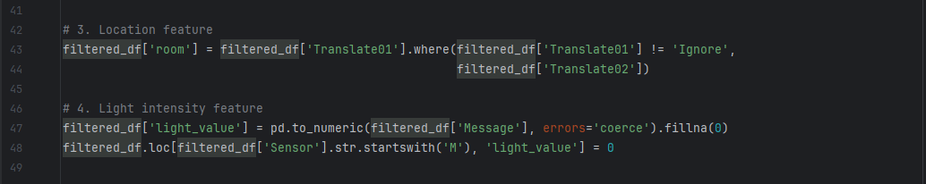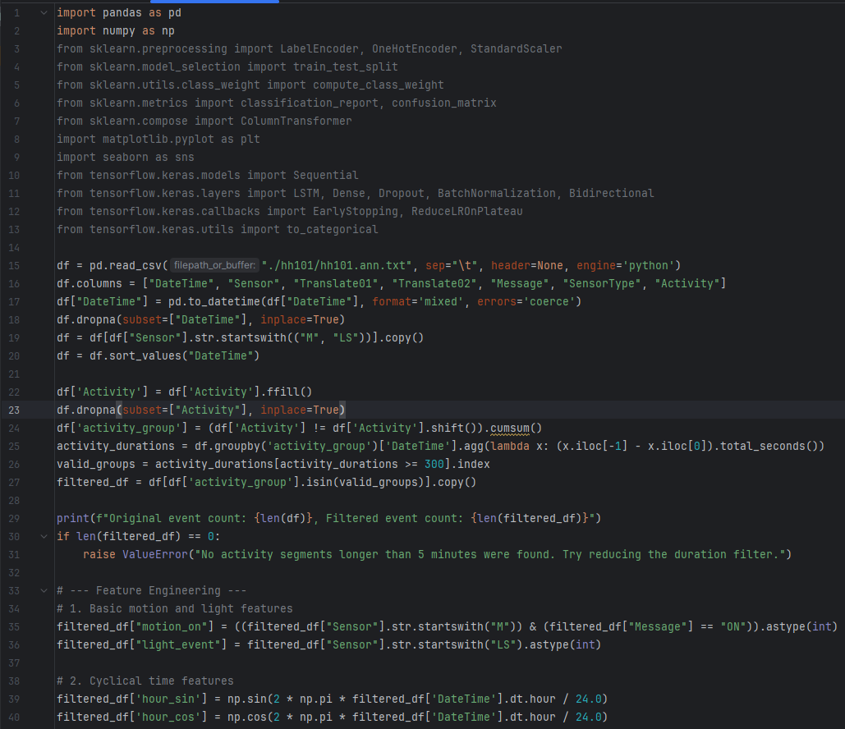**9.1 Data Preprocessing and Feature Engineering**

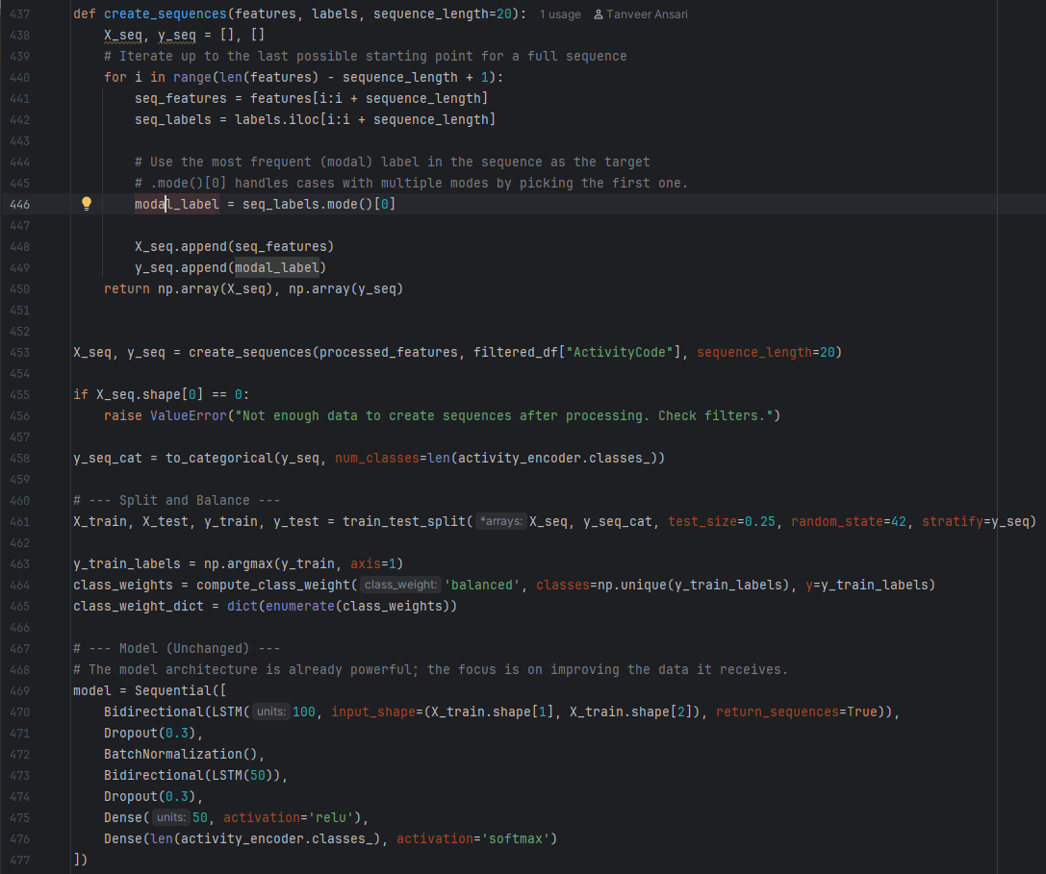**9.2 Bi-LSTM Model implementation**

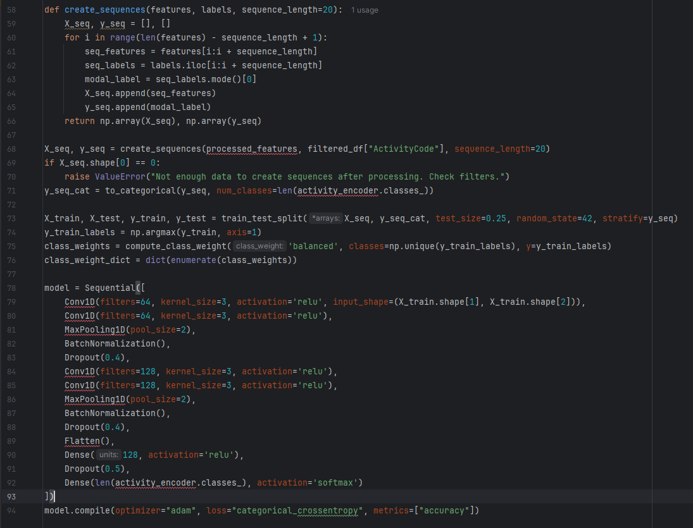**9.3 1D-CNN Model implementation**

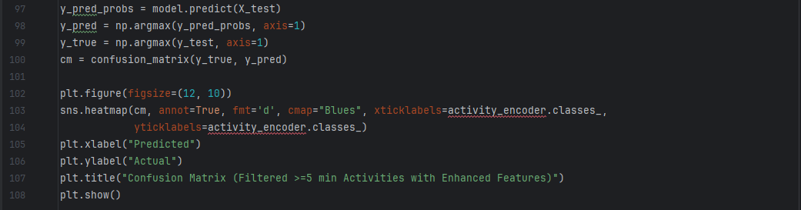**9.4 Model Evaluation and Visualization**

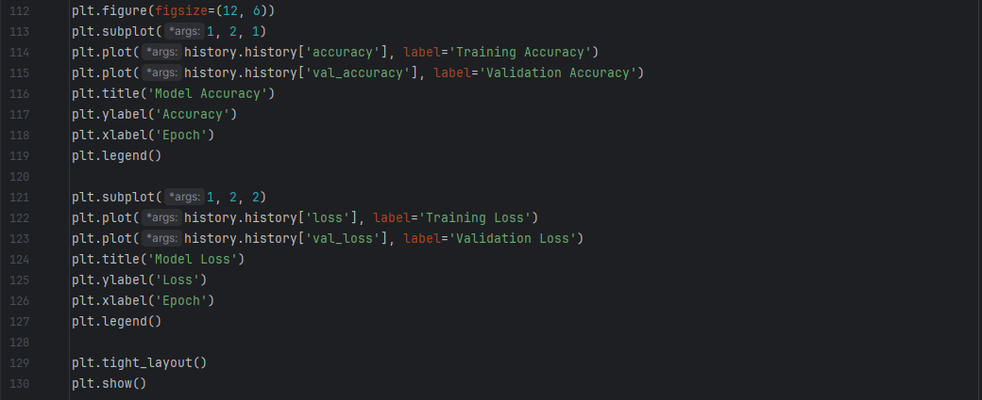**9.5 Comparative Visualization**